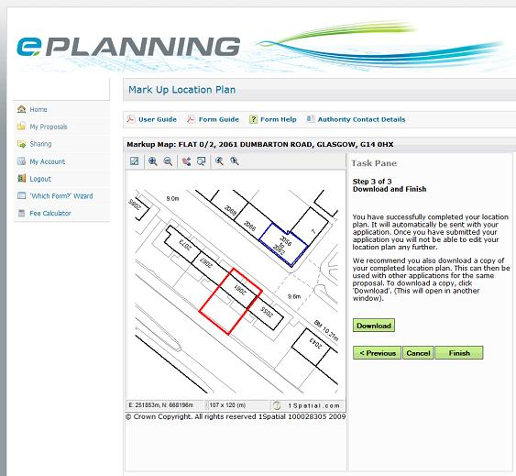
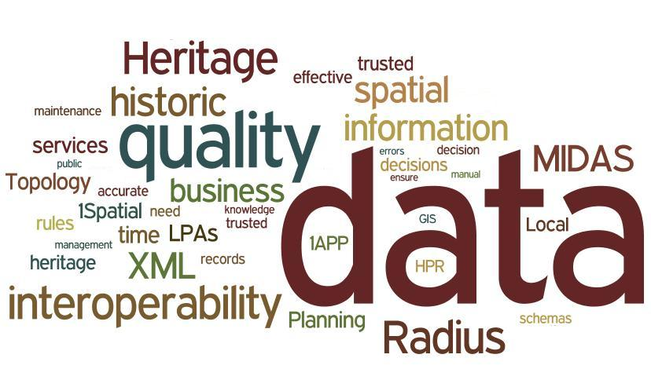

HER21 Towards HPR Compliant HERs:

Interoperability of HERS and Local Authority Planning Systems

EH Project 6035

State of the Art Analysis



Revision History

Date | Version | Author | Description
08/09/10 | 0.1 | Bob Chell | Initial Draft for basic framework and background.
08/09/10 | 0.2 | Bob Chell | Inserted review comments from English Heritage..
22/02/11 | 0.3 | Simon Payne | Initial comments from review of MIDAS and 1APP schemas.
01/03/11 | 0.4 | Bob Chell | Initial assessment from On-Line Surveys and Workshops.
07/03/11 | 0.5 | Bob Chell and Simon Payne | Initial Schema Mappings.
14/03/11 | 0.6 | Bob Chell | Data Validation Tools and Data Compliance.
21/03/11 | 0.7 | Bob Chell | Management Summary, Demonstator, Future Vision and Recommendations.
24/03/11 | 0.8 | Bob Chell | Update after review comments from Simon Payne.
04/04/11 | 1.0 | Bob Chell | Update after Final Presentation and Costed Options.

Authorisation

Role | Name | Signature | Date
1Spatial Chief Technology Officer | Paul Watson
English Heritage Project Manager | Sarah Reilly
1Spatial Project Manager | Joanne Shannon

Table of Contents
1 Background 6
1.1 Historic Environment Records 6
1.2 MIDAS Heritage UK Historic Environment Data Standard 6
1.3 Data Concepts 7
1.4 Project Stakeholders 8
1.5 Objectives 10
1.6 Scope 10
1.7 Project Interfaces and Related Initiatives 11
2 Business Process Overview 12
2.1 Purpose 12
2.2 Methodology 12
2.3 Current Situation 14
3 Existing Schemas 17
3.1 Purpose 17
3.2 List of Existing Schemas 17
3.3 Methodology 17
3.4 MIDAS Heritage XSDs 17
3.5 1APP XSDS 22
3.6 Summary and Conclusions 24
4 Existing Applications and Transformation Tools 26
4.1 Purpose 26
4.2 List of Existing Application 26
4.3 Methodology 26
4.4 Capability Matrix 27
4.5 exeGesIS SDM ltd 28
4.6 IDOX Group 29
4.7 Innogistic Ltd 30
4.8 Northgate 31
4.9 Civica UK Ltd 32
4.10 Swift DataPro ltd 33
4.11 ATRIUM Software Ltd 34
4.12 Resolution Data Management 35
4.13 Summary and Conclusions 36
5 Mapping to MIDAS Heritage UK Historic Environment Data Standard 38
5.1 Purpose 38
5.2 List of Sample Mappings 38
5.3 Methodology 38
5.4 HBSMR to MIDAS Heritage XML 39
5.5 English Heritage Listed Building System to MIDAS XML 39
5.6 LPA (IDOX) to MIDAS Heritage UK Historic Environment Data Standard 40
5.7 LPA (Swift) to MIDAS Heritage UK Historic Environment Data Standard 41
5.8 1APP <->MIDAS Heritage XML 41
5.9 MIDAS Heritage UK Historic Environment Data Standard to MIDAS Heritage XML 42
5.10 Summary and Conclusions 43
6 Data Validation Tools 45
6.1 Purpose 45
6.2 List of Data Validation Tools 45
6.3 Methodology 45
6.4 XML Validation 45
6.5 FISH Data Validation Tool 46
6.6 Radius Studio 49
6.7 Summary and Conclusions 50
7 Data Compliance 51
7.1 Purpose 51
7.2 List of Sample Data 51
7.3 Methodology 51
7.4 Compliance Matrix 51
7.5 MIDAS Heritage XML from HER Systems 52
7.6 MIDAS Heritage XML from English Heritage Listed Building System 53
7.7 GIS from LPA 54
7.8 GIS from HER 55
7.9 Bespoke XML from bespoke HER 56
7.10 Summary and Conclusions 57
8 Demonstrator 60
8.1 Requirements 60
9 Future Vision and Recommendations 61
Annex A. Tools and Applications - On-line Vendor Survey 68
Annex B. Tools and Applications - On-line User Survey 69
Annex C. User Workshops 70
Annex D. Schema Transformation Tools 71
Annex E. Data Compliance Level 79
Annex F. Schema Mappings 80
Annex G. Schema Transformation Levels 114
Annex H. MIDAS Schema Descriptions 115
Annex I. Terms and Definitions 117
Annex J. References 118

Management Summary
This research is one of a series for developing exemplars and good practice to deliver guidance for English Heritage to develop strategic goals and action plans for Heritage Protection Reform (HPR). A critical element of this reform is ensuring that useful, appropriate and accurate information is readily available to those making planning decisions about the character and components of the historic environment.
This report is based on interviews and workshops with HER and LPA officers, and independent review and analysis of current systems and their use of standards. Throughout the project, emphasis was placed on the practicality of existing systems and techniques, and also on the quality of the data available in the systems.
In scope were the information flows within 1APP compliant Local Planning Authorities (LPAs) Planning Systems, Historic Environment Records (HER) and the assessment of the spatial and textual data held within those systems against the MIDAS Heritage UK Historic Environment Data Standard.
It became clear during the analysis that the biggest challenge to interoperability is the amount of duplicated Heritage Asset data that currently exists in both Planning and HER Systems. In order to align with HPR, there is a need to raise the awareness and increase the importance of the HER. The mission statement for the HER must be to become the primary source of information on the Historic Environment and to proactively produce information. To improve interoperability the following recommendations should be considered when developing the strategic goals and action plans for the HPR programme.
The MIDAS schema has a number of features that could be improved upon to make it more succinct, internally consistent and useful as a component of an interoperable solution.
A central service should be developed to provide access to a national set of Heritage Asset information. This new service may form a natural extension to the existing Heritage Gateway, and act as a pull factor to encourage existing HEROs to subscribe. The service should provide an Archaeological Alert Map, which can be used by LPAs for prioritising and managing Planning Applications. This will encourage the LPAs to stop managing their own copies of the Heritage Asset data, reducing the amount of duplicated data and reducing the costs associated with managing it. The Alert Map will also help reduce the extent to which different advice is given by the HERO and LPA.
The Heritage Gateway should integrate more closely with the Planning Portal to provide better information to the HERO to support them in providing advice to the LPAs. This can empower the HERO to become more closely integrated into the consultative process. Providing prioritised weekly lists to the HERO will dramatically improve the efficiency with which they work.
The HER data should be improved by augmenting it with the LPA Heritage Data. This can drive an improved set of information to the HER, and therefore improve the accuracy and currency of all data delivered by the Heritage Gateway. MIDAS Heritage should be used to deploy quality control processes around this programme.

Background
This section provides a brief introduction to this HER 21 project; its purpose, concepts surrounding achieving compliance with HPR approaches, and the need for heritage data interoperability. It is intended for those who may be unfamiliar with Project 6035: Interoperability of HERs and Local Planning Systems Project Design Document (PDD), and sets the context for the State of the Art Analysis.
The findings in this report are based on independent review and analysis of current standards, notably the MIDAS Heritage UK Historic Environment Data Standard and 1APP.
The Business Process Overview is derived from On-Line surveys sent to the software providers and user community. On-Line surveys were further substantiated through Workshops.
Although the objective of this project was to focus on Interoperability between the LPA and HER, it is acknowledged that there are other business functions are supported by the HER.

Historic Environment Records
Historic Environment Records (HERs) are information services that provide access to comprehensive and dynamic resources relating to the historic environment of their locality for public benefit and use. Typically, they consist of databases linked to a Geographic Information System (GIS), together with associated reference collections and are managed by dedicated staff. Their content underpins the work of local authorities (and National Park Authorities) to identify, record, protect, conserve and interpret the historic environment designation and planning decisions.
Under Planning Policy Statement 5: Planning for the Historic Environment (PPS5), the importance of the HER is evident. It places increased emphasis on evidence-based planning decisions, places the HER as the core source of that evidence and also encourages data to be stored in GIS form, so it can be re-used for other spatial planning purposes such as Regional Spatial Strategies (RSS) Local Development Framework (LDF), Sustainable Communities Strategy and Local Area Agreements. It also looks to encourage early engagement in the planning process through ‘pre-applications/development investigations’, which also places greater importance on recording information on heritage assets and ensuring that the results are properly stored in the HER.
A impact assessment of PPS5 [1] illustrated that a streamlining of the process (that places the use of the HER at its core) to make a 1% efficiency saving could save the LPAs in the order of £3.52m p.a. in relation to applying for planning permission, listed building consent and conservation area consent.

MIDAS Heritage UK Historic Environment Data Standard
The MIDAS Heritage UK Historic Environment Data Standard [2] is designed to provide a common framework within which information systems that manage Heritage Assets should develop. The desired result is that this framework then promotes effective sharing of knowledge and its long-term preservation. The standard mandates what information/data should be recorded about the historic environment. It is then the role of HER professionals to supply advice about the Historic Environment that makes use of evidence managed in the HER.
MIDAS Heritage builds on the first edition of this data standard, created in 1998. Full lists of changes that have taken place since this first edition are documented in The MIDAS Heritage UK Historic Environment Data Standard [2].
The standard is also intended to complement existing standards including SPECTRUM, UK GEMINI Discovery Metadata Standard, e-Government Metadata Standard (e-GMS) and CIDOC Conceptual Reference Model (CRM).
The primary vision of this standard is to promote the sharing of data relating to the historic environment. To support the heritage community needs, the Forum on Information Standards in Heritage (FISH) [3] established as suite of technical standards and protocols that together are called the FISH Interoperability Toolkit [4].

Data Concepts
XML is regarded as an important element of the MIDAS Heritage UK Historic Environment Data Standard, and it has already been documented in English Heritage’s Heritage Data Management Information Sheet, XML for the historic environment: an introduction [5], produced in 2004.
Although the MIDAS Heritage UK Historic Environment Data Standard does not specify a database schema, it does state that the HER system used must have the functionality to store and export the Units of Information required by the standard. The MIDAS Heritage XML Schema should be considered as a vehicle for Heritage Asset data exchange.
A set of XML schemas have also been developed to support on-line planning. LPA Planning Systems can be certified against this standard (known as 1APP). The integration of the on-line planning systems with the 1APP XML Schemas is a good example of e-GIF (electronic Government Interoperability Framework) compliance. The e-GIF defines the technical policies and specifications governing information flows across government and the public sector [6] and mandates the adoption of XML to support government interoperability and integration strategy. These information flows have already been documented in a report from SOCITM [7].
The activities and deliverables of this project as described in the preceding sections will contribute to achieving English Heritage’s corporate objective 4A, i.e. “Help local authority members and officers develop the skills, knowledge, advice, and capacity to make the most of their historic environment”.
Although the exchange of data between HERs, Local Authority Planning Systems, and English Heritage is not solely about geospatial information, the underlying aim and objectives of this project are also well reflected and summarised by the Strategic Actions of the UK Location Strategy. These provide an excellent framework of concepts that are equally relevant to this HERs interoperability project:
- “we know what data we have and avoid duplicating it”
- “we use common reference data so we know we are talking about the same places”
- “we can share location-related information easily through a common infrastructure of standards, technology, and business relationships”
To adapt these specifically for the HERS interoperability project, a successful eventual outcome reads as follows:
- “we know what historic environment data we have so we can avoid duplicating it”
- “we use common reference data so we know we are talking about the same historic environment records and data”
- “we can share historic environment-related information easily through a common infrastructure of standards, technology, and business relationships”

Project Stakeholders

Customer Stakeholder Summary
Name | Description
Name | Responsibilities
English Heritage | English Heritage is the Government's statutory adviser on the historic environment. Officially known as the ‘Historic Buildings and Monuments Commission for England’, who are an executive non-departmental public body sponsored by the Department for Culture, Media and Sport. English Heritage’s principal powers and responsibilities are set out in the National Heritage Act (1983).
English Heritage | English Heritage have responsibility in assisting Local Planning Authorities (LPAs) to develop HERs which comply with HPR approaches and which enhance the evidence base for effective planning.  English Heritage in partnership with the Institute of Historic Building Conservation (IHBC) and the Association of Local Government Archaeological Officers (ALGAO) is developing a strategy for HPR compliant HERs. It is envisaged that implementation of this strategy will take place between 2010 and 2015, subject to funding being available.

Name | Description
Name | Responsibilities
RTPI | The ‘Royal Town Planning Institute’ (RTPI) is the leading professional body for spatial planners in the United Kingdom. It is a charity with the purpose to develop the art and science of town planning for the benefit of the public as a whole. It has over 22,000 members who serve in government, local government and as advisors in the private sector.
RTPI | The project will need to ensure buy-in with the planning sector, which is obviously closely involved in the development of policy for and the management of the historic built environment.

Name | Description
Name | Responsibilities
FISH | The Forum on Information Standards in Heritage (FISH) is a forum to co-ordinate, develop, maintain and promote standards for the recording of heritage information.
FISH | The HERs interoperability project needs to interface with FISH, which has responsibility for the maintenance and updating of MIDAS Heritage. It also needs to liaise with the ‘FISH Interoperability Toolkit Revision and Extension Project’ to inform the review of options for delivering interoperability.

Name | Description
Name | Responsibilities
IHBC | The ‘Institute of Historic Building Conservation’ (IHBC) is the professional body of the United Kingdom representing conservation specialists and built and historic environment practitioners in the public and private sectors. The IHBC exists to establish, develop and maintain standards of conservation practice, to support the effective protection and enhancement of the historic environment, and to promote heritage-led regeneration and access to the historic environment for all.
IHBC | The project will need to ensure buy-in with the professional body, who are closely involved in the establishing the highest standards of conservation practice, to support the effective protection and enhancement of the historic environment, and to promote heritage-led regeneration and access to the historic environment for all.

Name | Description
Name | Responsibilities
ALGAO | The ‘Association of Local Government Archaeological Officers’ is a professional body for senior professional archaeologists (employed directly within a local authority or in some cases by independent joint services) whose primary responsibility is to advise that authority, principally through the planning process, on conservation and management of the archaeological resource within the boundaries of that authority.
ALGAO | This project will need to ensure buy-in with this professional body, which is responsible for working in collaboration with national agencies and other organisations to develop data standards, ensure greater consistency in recording practices, and to increase accessibility of information to the public.

User Summary
Name | Description
Name | Responsibilities
HER Professional | Local Authorities and most National Park authorities maintain records of the archaeological, built and natural environment. Specialist staff are employed to curate these records and also to provide specialist advice for land-use planning and public information services. Some major landowners, such as the National Trust and the Ministry of Defence, also maintain similar records, which are used to manage their landholdings for conservation, but not for development control purposes.
HER Professional | The HER Professional will be responsible for using any transformation service that arises from this project, and for providing input into the project in the form of on-line surveys and on-site assessment days.

Name | Description
Name | Responsibilities
LPA Planning Professional | Provide evidence-based decisions on the planning process when dealing mainly with a planning or consent application.
LPA Planning Professional | The LPA Planning Professional will be responsible for using any transformation service that arises from this project, and for providing input into the project in the form of on-line surveys and on-site assessment days.

Name | Description
Name | Responsibilities
Applicant | An applicant may submit multiple types of planning applications to the LPA, either by paper or electronically (e.g., via the Planning Portal).
Applicant | The Applicant will be responsible for submitting the Planning Application and acting upon the decision received on their submission from the LPA.

Objectives
The overall project objective is to help English Heritage decide on the best HERs interoperability approach going forward; this project therefore aims to explore Local Authority Planning Systems current level of compliance with the MIDAS Heritage UK Historic Environment data standard and whether they have the potential to be interoperable with HERs.
The primary objective of the project is therefore to produce a ‘State of the Art Analysis’ Report that:
- Selects a number of representative LPA Planning Systems to analyse and summarise the functionality and tools/modules currently available within these that relate to the historic environment.
- Assesses the selected LPAs Systems, with planning databases compliant with the 1APP XML protocol, capability to deliver historic environment records data that are compliant with HERs MIDAS Heritage XML.
- Undertakes a ‘gap analysis’ of LPA systems that are non-compliant and assesses how close they are to compliance so that they could use the MIDAS Heritage XML schema as a vehicle for HPR data exchange, (i.e. identify what is currently missing).
- Identifies what needs to be done to improve data interoperability, i.e. what useful data is captured and stored in LPAs’ systems, but not currently available to the HER.
- Identifies key functional and non-functional requirements for schema transformation.
- Identifies solutions for achieving and underpinning efficient interoperability of trusted data and presents candidate recommendations and costed options for providing a suitable transformation service(s) that would allow LPAs to submit data from their Planning Systems in a range of specified formats and schemas and:
  - Receive a report of non-compliances
  - Be offered options to fix non-compliant data as per specific ‘business rules’
  - Have compliant data transformed to MIDAS Heritage schema
  - Receive compliant data back in MIDAS Heritage XML files
  - Receive a date stamped compliance report that assures compliance with the MIDAS Heritage UK Historic Environment Data Standard; thus meaning it is usable as a HERs input into the HPR initiative
- Implement a demonstrator that, based on the content of the ‘State of the Art’ Analysis, illustrates how such a transformation service could be supported, and in so doing validate its accuracy and usability.

Scope
The following elements of the project are considered to be in the scope of this project:
- Planning Systems Software vendor survey
- Local Authority and National Park user community survey
- LPA and HER site visits
- MIDAS Heritage-compliance analysis & assessment
- Transformation options analysis
- Demonstration of one particular transformation option
- Creation, delivery and presentation of ‘State of the Art Analysis’ report to English Heritage
The flow of these elements can be envisaged in Figure 1 - Project Activity Flow.
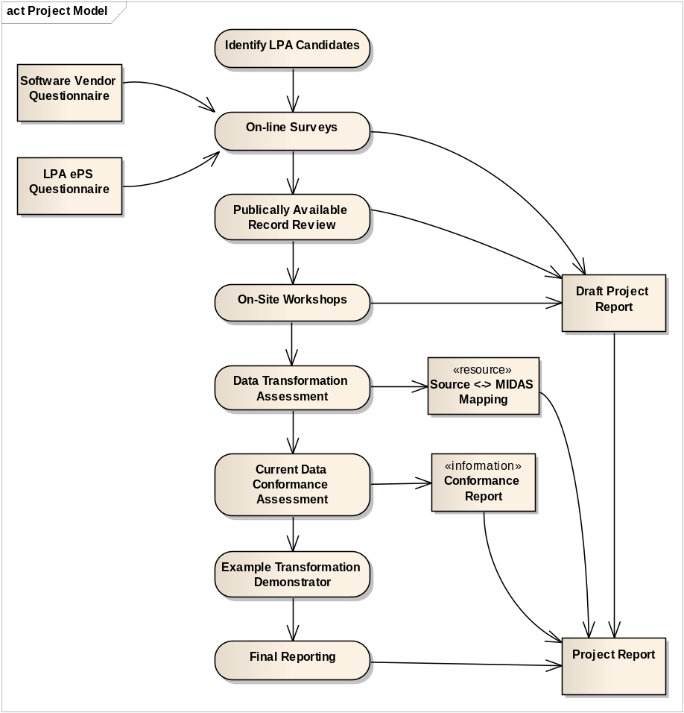
Figure 1 - Project Activity Flow

Project Interfaces and Related Initiatives
- Project 6032 - The Historic Environment Officer Managing an HPR Compliant HER.
- Project 6033 - HER-Derived Alert and Constraint Mapping Supplied to Local Authorities.
- Project 6034 - The development of GIS data standards for use in HERs in England.
- Forum on Information Standards in Heritage, and specifically the FISH Interoperability Toolkit Revision and Extension Project
- The Royal Town Planning Institute

Business Process Overview

Purpose
This section details the collection of tasks that allow users of historic environment records to record and share their information. It will aim to take a comprehensive view of the existing business processes and the way that they currently interoperate.
It must be noted that focus on business processes here is based on that with the LPA, and it is acknowledged that many other business functions are supported by the HER.

Methodology
An on-line survey was conducted to obtain information from the users about the ways in which they LPA Planning Systems and HERs interoperate. Once responses were received, further information was obtained from various past projects and on-line literature, to validate the information from the surveys.
Finally, workshops were organised with HERO and LPA Planning Officers, where the business processes surrounding the use of Heritage Asset data were discussed in more detail.
The on-line survey contained questions related to:
- The awareness of applicable standards and practices
- The use of historic environment data in planning, and planning data in providing advice about planning and historic environment
The User Survey was sent to a pre-defined list of HERs using the on-line survey tool www.surveymonkey.com. The author would like to thank Bruce Howard (English Heritage) for his assistance in the creation of these surveys, and in addition Gillian Grayson for their support in helping identify the candidate HERs. 56 HEROs provided excellent feedback through the on-line survey.
The full set of questions is provided in Tools and Applications - On-line User Survey.
The workshop agenda is provided in User Workshops.
The HERs were selected to gain a representative view of current situation. This considered –
- different types of HER Systems (e.g. HBSMR, Custom, different databases, different GIS)
- a range of structure in terms authority (e.g. National Park. Unitary, County Council)
- a range of geographical locations (busy M25 HERs, rural coverage, urban coverage)
These HERs can be visualised geographically in Figure 2 - HERs Identified for Workshops.
Workshops were conducted with 8 HERs and two vendors. The 2 vendors were selected based on the User survey results, which identified the most popular HER System and Planning System. The author would like to thanks the individuals in and organisations that kindly responded –
- Lake District National Park - Eleanor Kingston (HER) Lucy Embery (Planning)
- Hertfordshire County Council - Alison TInniswood, Isobel Thompson, (HER), Iain Leech (Planning)
- Durham County Council - Nick Boldrini (HER)
- Somerset County Council - Chris Webster, Naomi Payne (HER), Ed Baker (Planner)
- Staffordshire County Council - Suzy Blake (HER), Holly Francis, Angela Grove (Planner), Lee Wells (GIS)
- Warwickshire County Council - Ben Wallace (HER), Teresa Muddeman, Dan Robinson (Planner), Huw Davies (GIS)
- Suffolk County Council - Colin Pendleton, Sarah Poppy (HER), Christine Leveson (Planner)
- Newcastle City Council - Jennifer Morrison (HER)
- Cambridgeshire County Council – Sally Thompson, Quinton Carrol (HER)
- IDOX - James Sealey
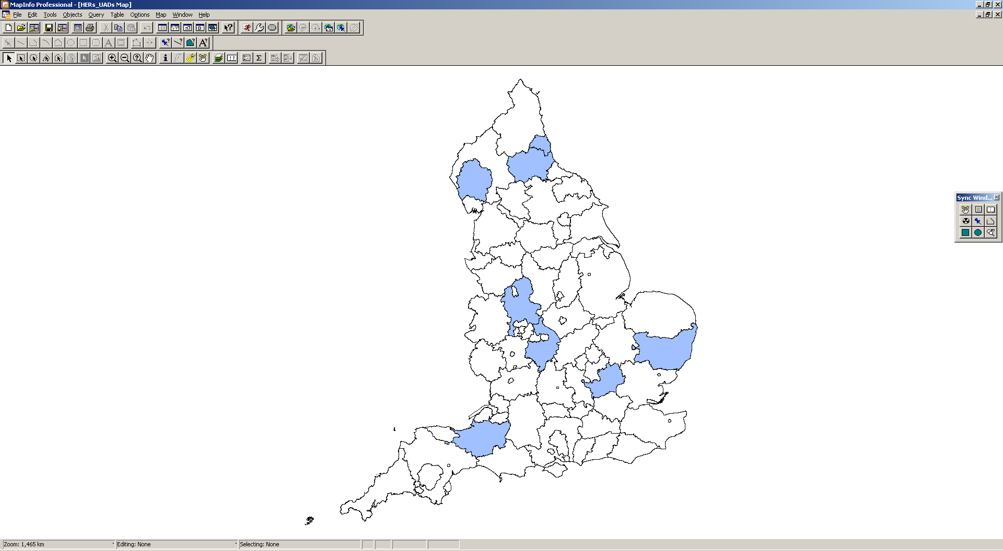
- exeGesIS SDM – Crispin Flower
Tyne and Wear
Durham
Suffolk
Lake District
Somerset
Staffordshire
Warwickshire
Hertfordshire
Figure 2 - HERs Identified for Workshops

Current Situation
Below is a list of current observations made from the initial surveys and workshops. It is acknowledged that the findings here also support past reports and studies, such as those from SOCITM [7] and ALGAO [8].These are the unbiased list of findings, substantiated through the workshops and surveys.
Cultural and Behavioural
  - There are many different types of HER structure –two tier, partnerships, authority hosts own HER.
  - HER teams are often separate from the Planning teams, even when hosted by same authority. This was evident in trying to coordinate the workshops where we looked to invite Planning and HER officers. The only exception to this was in the Lake District National Park, which was small enough for the two teams to sit in close proximity.
  - Validation Lists include a varied, but important first insight into the use of the HER. They set out the national requirements that are necessary to validate a planning application. The Validation Lists sometimes explicitly reference the use of the HER. In all cases experienced during this study, the Validation List was available as an on-line resource.
Co-ordination and Co-operation
  - There is no evidence of any Planning Systems with direct access to the HER.
  - Various levels of interaction were demonstrated between the HER and LPA, with the only real exception around involving very large developments where the HER is always consulted. The observed levels of interaction included -
    - Automated e-mail alert from LPA to the HERO based on Alert/Trigger Maps
    - Automated Check List for LPA to identify if consultation with the HERO is required, this being based on Alert/Trigger Maps
    - Professional interpretation of the Planning Officer using a set of Archaeological data in the form of a GIS file
    - No interaction and the HERO pro-actively checks published Weekly Lists
  - The HEROs demonstrate a vast array of skill in supplying data to their customers in a variety of formats. They perform this to support multiple LPAs, all using different Planning Systems. However, predominately the information passed from the HER to the LPA can currently be classified as either a ‘report’ or a GIS file.
  - In addition to the transfer for specific requests into the HER, approximately 50% of the HERs that responded make Heritage Asset information available to the Heritage Gateway. This is a valuable resource for reference, but in the views of the HEROs, not suited for use in the planning process because it does not provide enough detailed information. Some HEROs have complimented the Heritage Gateway by making information available through their own websites.
  - LPAs often rely on their own information on the built environment, and not the HER. Often, their Heritage Asset datasets originate as data downloaded from the English Heritage website, or occasionally is published from the HER. However, on receipt on this data, the LPA may extend their view of this data in a variety of ways – e.g. creating polygons from the point data, appending new Local Listings as they occur. These updates are not always shared with the HER. Figure 3 - Listed Building Data from English Heritage, HER and LPA, shows where there are clear mismatches between the three views of the Listed Buildings for this particular area, as well as data duplication.
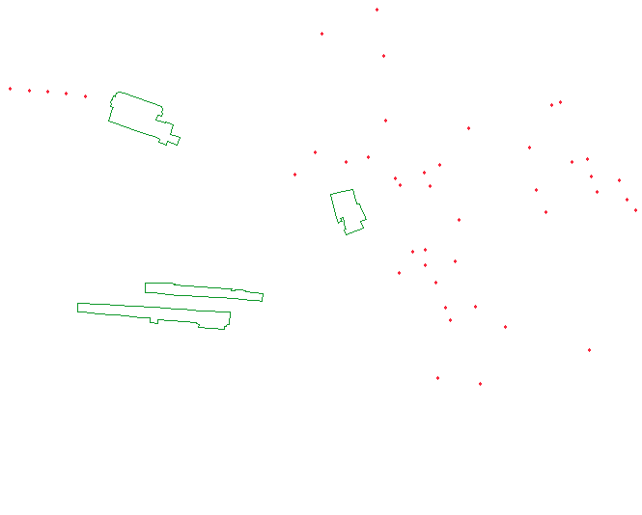

[a] Listed Building Polygons
(downloaded from English Heritage)
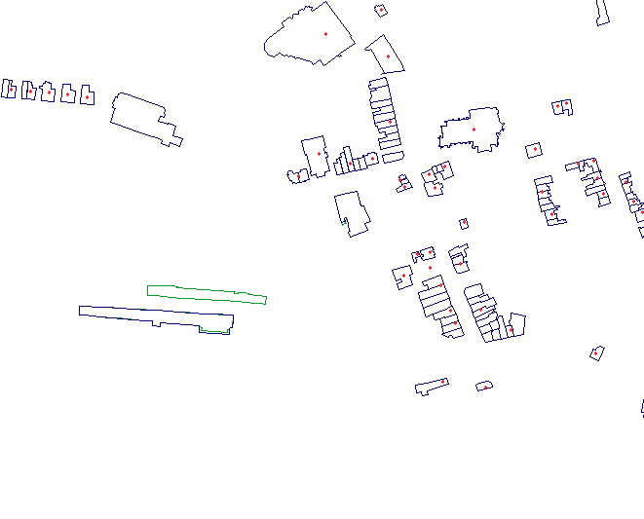
[b] Listed Building Polygons
(English Heritage data overlaid with HER Listed Building data)
[c] Listed Building Polygons
(English Heritage, HER data overlaid with LPA Listed Building data)
Figure 3 - Listed Building Data from English Heritage, HER and LPA
Consultation
  - Although the use of a Consultation’s module was not evident in all HERs for managing and recording interaction with the LPAs, where it was in use, it was considered extremely valuable by the HERO. It provided evidence of interaction volumes with the Planning function and for the provision of audit trails throughout the Consultation. However, it was also noted that the HER does not have any automatic mechanism for recording the final outcome of the consultations that they have advised on, and easy integration to gain this type of information would be seen as beneficial.
  - Where consultation modules are in place, they often begin with an administration task to document the Planning Application details into their own HER system. This immediately duplicates data, and also places a pressure on the administration task to input the data before the HERO can perform their critical role of interpretation and supplying advice.
Standards
  - Almost the entire HER community is aware of MIDAS and claim that they are using the MIDAS Heritage UK Historic Environment Data Standard as their data standard. However there does appear to be some confusion over some of the terminology (e.g. MIDAS, MIDAS Heritage) and also in knowledge around the status of the current MIDAS schema. All examples of MIDAS XML supplied by the HEROs were based on the MIDAS XSDs version 1.0. The FISH site itself currently references version 1.1, with a version 1.2 imminent. And despite the acknowledgement that the standard is in us, most users have never made use of the FISH Interoperability Toolkit (see – Have you ever used the FISH Interoperability Toolkit?).
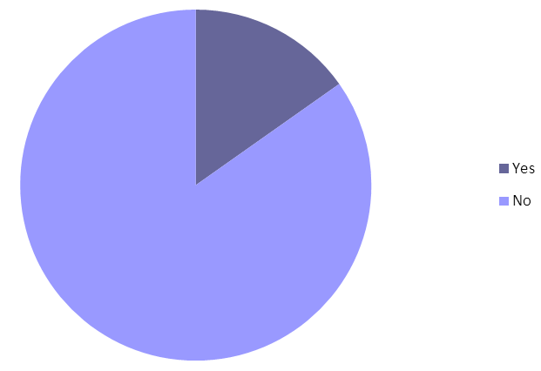
Figure 4 – Have you ever used the FISH Interoperability Toolkit?
  - The workshops revealed that although many HEROs answered ‘Yes’ (in some form) to the use of MIDAS XML in their HER, this was predominately a one off exercise that was required to import Listed Building data, supplied by English Heritage, into their system. The major system suppliers, IDOX and exeGesIS SDM, also referenced these ‘one-off’ loading operations that took place as the only real demonstration and use of MIDAS XML. And during that, an observation that was made was the loss of a set of ‘address information’ because the model did not support it (this is also noted in the evaluation of the XSD schemas in Existing Schemas).

Existing Schemas

Purpose
This section details the schemas used by the HER and LPA Planning Systems, including mandatory and optional features. Tools that assist in the analysis of these schemas will be documented in section Existing Applications.

List of Existing Schemas
- MIDAS Heritage XSD
- 1APP XSD

Methodology
The schemas were compared against their Data Specification and examined using Enterprise Architect and XML Spy.

MIDAS Heritage XSDs

Schema Description
- MIDAS Heritage is a rich schema for capture of data relating to all aspects of conservation of heritage and knowledge of the historic environment. It is part of the FISH suite of XML schemas for the historic environment [2]. It is composed of twelve MIDAS domain schemas and three HEEP schemas (the latter define a web services’ protocol for querying historic environment records). See MIDAS Schema Descriptions for a list of MIDAS schemas and their descriptions.

Detailed Evaluation
This is a richly developed schema that provides wide scope for storage and maintenance of historic environment data, not just at a snapshot in time, but as a layer of changing understandings of the historic environment, reflecting the increase in knowledge over time. It is very flexible to cater for differing needs of users.
All elements are defined as within the single ‘midas’ namespace, whereas there is scope for increasingly the expressiveness of the schema by adding extra namespaces, as is seen for example in the UK GEMINI metadata schema which defines geographical discovery related metadata terms.
There is some inappropriate typing of data objects (e.g. use of xs:string for dates). For example, in the midas_casework schema’s decision element definition. This element type has ‘datereceived’ and ‘dateofrecommendation’ but both are defined as the default xs:string. This would mean that, for example, ‘25th December 2011’ and ‘2011-12-25’ are equally acceptable (as, for that matter, is a free-text description) whereas the date could have been captured in a more precise way, both facilitating machine-validation and indexing of data for the purposes of automated search.
For example, below there are three extracts from the MIDAS Heritage XML files that refer to the Designation and Protection Information Group. What you will noticed is the missing information (IE the Date) between extract 1 and extract 2, and the difference in format of the data (IE the Date) between extract 1 and extract 3.
Extract 1 – Designation
<designations>
<designation>
<status>Listed Building</status>
<grade>II*</grade>
<date>1983-12-14T00:00:00</date>
</designation>
</designations>
Extract 2 – Designation
<designations>
<designation>
<status>Listed Building</status>
<grade>II</grade>
<date/>
</designation>
</designations>
Extract 3 – Designation
<designations>
<designation>
<status>listed building</status>
<grade>II</grade>
<date>17-APR-1986</date>
</designation>
</designations>
The above example refers to the difference in value formats. This second example shows differences in description, where the ‘type’ of information that is part of the Date and Period Information Group, does not match. In extract 1, the type for the Start Date is referenced by the appellation type ‘mindate’ and in extract 2 it is referenced by the appellation type ‘Min Date’.
Extract 1 – Date and Time
<monumenttype namespace="EH_TMT2">FINDSPOT</monumenttype>
<temporal>
<span>
<display>
<appellation/>
</display>
<start>
<appellation type="mindate" qualifier="">43</appellation>
</start>
<end>
<appellation type="maxdate" qualifier="">409</appellation>
</end>
</span>
</temporal>
Extract 2 – Date and Time
<temporal>
<span>
<display>
<appellation/>
</display>
<start>
<appellation type="Min Date"/>
</start>
<end>
<appellation type="Max Date"/>
</end>
</span>
</temporal

Looking ahead, this tightening of data typing will support not just more efficient and easier to encode transformation routines, but also integration of MIDAS compliant datasets with linked data initiatives [9].

<xs:element name="datereceived">
<xs:annotation>
<xs:documentation>Date the proposal was received for advice
</xs:documentation>
</xs:annotation>
</xs:element>
<xs:element name="recommendation">
<xs:annotation>
<xs:documentation>Recommendation made by the HE inventory
manager relating to the proposal.
</xs:documentation>
</xs:annotation>
</xs:element>
<xs:element name="dateofrecommendation">
<xs:annotation>
<xs:documentation>Date of issue of the recommendation.
</xs:documentation>
</xs:annotation>
</xs:element>
There are inconsistent typing and style between different XSDs, giving the impression of distributed but non-collaborative authorship (e.g. xs:group used in some places, xs:element in others, to define open collections of elements).
It is not clear from study of the schemas what the use cases are for the schema. Very little is mandated in the schema. For example, in midas_monument, inside a monuments element there has to be at least one monument and that must have an appellation, but apart from that nothing else is required of the monuments element. The schema gives the impression of being intended as a catalogue for a wide range of unspecified uses rather than as a model that forms the basis for a system delivering specific business goals.
There is also evidence of reinventing element definitions in many places rather than defining types in one common location and inheriting those definitions throughout the schema (little use of xs:element ref=”common-type-defined-elsewhere”). For example, in midas_monument the ‘material’ element is defined as:
<xs:element name="materials" minOccurs="0">
<xs:annotation>
<xs:documentation>
Element used to hold numerous materials.
</xs:documentation>
</xs:annotation>
<xs:complexType>
<xs:sequence>
<xs:element name="material" minOccurs="0" maxOccurs="unbounded">
<xs:annotation>
<xs:documentation>
A single monument material.
</xs:documentation>
</xs:annotation>
</xs:element>
<!-- Begin /monuments/monument/characters/character/type/materials/material -->
</xs:sequence>
</xs:complexType>
</xs:element>
Whereas in midas_object the same element is defined again:
<xs:element name="material" maxOccurs="unbounded">
<xs:annotation>
<xs:documentation>The material that this object consists of
</xs:documentation>
</xs:annotation>
<xs:complexType>
<xs:simpleContent>
<xs:extension base="xs:string">
<xs:attribute name="namespace" use="optional">
<xs:annotation>
<xs:documentation>From what resource (thesaurus) is this material type derived?
</xs:documentation>
</xs:annotation>
</xs:attribute>
</xs:extension>
</xs:simpleContent>
</xs:complexType>
</xs:element>
These could have been replaced by a single common type definition and use of references, coupled with a distinct namespace for common element definitions, such as:
<xs:element ref=”common:material”/>
which is much more succinct and enables the development of the model to be done efficiently without unnecessary repetition and the discrepancies that can arise from it. If desired, it would then be possible to introduce distinct subtypes for object materials and monument materials.
There are some unusual choices of element and group names. For example, in midas_monument.xsd the group ‘type’ and the element ‘type’ are defined. This is highly confusing for a reader of the schema: a) there is no indication of what kind of type this is; b) is this an element or a type definition? Clearly, it is defining a group in the one case and an element in the other, but an understandable semantic confusion arises despite the syntactic clarity afforded by the XML Schema language.
<xs:group name="type">
<xs:sequence>
<xs:element name="type" minOccurs="0" maxOccurs="unbounded">
<xs:annotation>
<xs:documentation>Records monument type and associated data. This is a recursive, nested element.
</xs:documentation>
</xs:annotation>
<xs:complexType>
There is no use of xlink type structures which could add a greater effectiveness to the schema by defining foreign key relationships between different but related types of object (e.g. artefacts and contacts). Instead, as e.g. in midas_object, there is a midas:related element which gives space for links to related objects. The related element is defined in midas_common.xsd to permit links to monument, resource, object and casework instances. It would be better to use XLink attribution for such references as it is a recognised standard, more powerfully expressive, providing, for example, bi-directional links. XLinks could also be used for expressing links to remote resources such as those defined in midas_reference.
Annotations often imply business logic that is not actually captured in the definition of the XML elements (e.g. enumerated lists such as 'waterlogged', 'mineralised', 'dessicated' are cited in the comments but not incorporated in the XML typing restrictions so as to check, by means of XML validation, for use of the appropriate terms). For example, in the midas_object.xsd schema, this definition is present:
<xs:element name="preservation" minOccurs="0">
<xs:annotation>
<xs:documentation>Status of the object relating to its state of preservation ('waterlogged', 'mineralised', 'dessicated', etc.) This is not STATE, a qualitative statement of condition. An object could be in bad condition, but waterlogged therefore retaining value for some types of investigation.
</xs:documentation>
</xs:annotation>
<xs:complexType>
<xs:simpleContent>
<xs:extension base="xs:string">
<xs:attribute name="namespace" use="optional">
<xs:annotation>
<xs:documentation>The namespace from which the value is derived
</xs:documentation>
</xs:annotation>
</xs:attribute>
</xs:extension>
</xs:simpleContent>
</xs:complexType>
</xs:element>
This could be redesigned so that the ‘namespace’ attribute is defined as an extension of an enumerated type.

1APP XSDS

Schema Description
This is documented in the Planning Portal, Planning Data Standards, Data Interchange Architecture [10]. See component diagram in Section 2.1 of that document.
- Contacts Schema
The contacts schema is the main application schema containing the definition for interchange of contact records for the Contacts Directory to be implemented on the Planning Portal.
- Development Plans Schema
The Development Plans schema is the main application schema containing the definition for interchange of development plans. Development plans are documents produced and maintained by LPAs as part of the Local Development Framework for their area and any additional policies that have been added to it by the local authority. These also incorporate national planning policies and regional structure plans. These factors influence strongly the outcome of a planning application, depending on its content. However, they are distinct from the planning application from a business workflow point of view.
- Applications Schema
The Application schema is the main application schema containing the definition for interchange of Planning Applications.
Application schema defines a series of types of application that feed into the planning process. The Planning Portal website lists the types of planning permission that may be sought [11].
There are eight types of planning application catered for by the 1APP schema, which are a subset of those described on the Planning Portal information pages, and are described, in the Table 1 - Planning Application Types, along with descriptions of their purposes.
Application | Description
Advertisement Consent | For proposals to display an advertisement or sign which requires planning permission.
Householder | For proposals to alter or enlarge a single house, including works within the boundary/garden of a house.
Listed Building | To apply for consent to:  demolish a listed building  alter or extend a listed building in a manner which would affect its character as a building of special architectural or historic interest
Planning Application | To apply for full planning consent, which means to make a detailed planning application for development, excluding householder developments. For the purposes of this form, development includes building, engineering or other works, in, on, over or under land, or the making of any material change in the use of any buildings or other land.  or  To apply for outline planning consent, which seeks to establish whether the scale and nature of a proposed development would be acceptable to the local planning authority, before a fully detailed proposal is put forward.
Lawful Development Certificate (LDC191/LDC192) Application | Seeks to establish whether an existing or proposed use of a building is lawful or that the proposal doesn’t require planning permission.  LDC 191 relates to existing uses and LDC 192 relates to proposed uses of land.
Woodland Application | To apply for permission to develop forest land for purposes such as building roads, engineering works or construction of buildings.
Breach Complaint | Enables the reporting by the public or community groups of developments that may have breached a planning control to permit enforcement by the local planning authority.
Table 1 - Planning Application Types
These are supported by the following schema namespaces: -
  - PINS Types: a set of common object definitions used by the 1APP schemas.
  - BS7666: standardised address formats [12].
  - Modified Dublin Core Element Set (see ISO 15836 and Dublin Core [13]): standard proposing fifteen generic metadata terms, the basis for the UK Government’s e-Government Metadata Standard (the e-GMS [14], now superseded by the e-GIF [15]).
  - XLink: [16] tables definition of inter-object relationships within XML documents conforming to the 1APP Schema.
  - Modified GML Packet based on OGC’s GML 2.0 [17] and XLink (see above).

Detailed Evaluation
This is a well-constructed schema developed in 2002 with the needs of flexibility to meet future requirements. It incorporates a number of international and UK standards such as XML Schema, XLink, BS7666 and GML. Schema is designed principally for the definition and processing of planning applications. It is not a consultation schema. In fact, there is no consultation element in it. This is a substantial problem in seeking to migrate data from LPA Planning System systems to MIDAS-compliant systems. Extra classes would need to be interpolated between the Planning System and MIDAS domain models in order to provide the necessary endpoints for transformation of this information.
The schema uses inheritance effectively. See e.g. the extract in Figure 5 - Excerpt from class diagram showing examples of inheritance in PF-Forms-v2-0.xsd which is taken from a UML model generated from PPForms-v2-0, which is included to show the extent of class inheritance employed in the schema. Inheritance, a feature of object-orientation, is beneficial because it encourages re-use of existing definitions of elements and attributes rather than development of parallel structures in different schemas. Thus, it streamlines the development of schemas, reducing their length and focussing component design on core functionality.
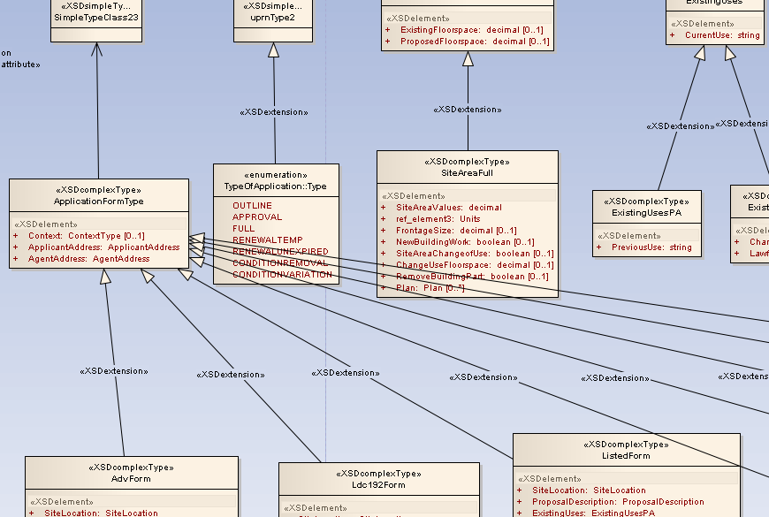
Figure 5 - Excerpt from class diagram showing examples of inheritance in PF-Forms-v2-0.xsd
This is strongly aligned with business processes and data lifecycles of LPAs. There is some redundancy in the schemas, especially since introduction of v. 2.0 of the schemas.

Summary and Conclusions
MIDAS schema is essentially designed to support curatorial, heritage designation and similar activities, and reflects the lifecycle of data within the context of a contemporary understanding of the historic environment. In contrast, the 1APP schema is designed for the purposes of planning authorities.
Information is always managed in the context of a business workflow. To consider a trivial example, an application form has, at the minimum, a pre-submission status, a submitted status, and a post-evaluation status (whether approved or denied). Likewise, MIDAS heritage information is gathered and curated within a sophisticated workflow that makes full use of the expertise of the staff who manage it.
Correspondingly, information items gathered and maintained within this curatorial context have a data lifecycle that, in practice, will reflect the business context. When considering the MIDAS XSDs, however, there is no clear support for such data lifecycle events that might key into this business workflow. To take for example, the MIDAS monument schema - whilst monument records do have record metadata that includes the date of update, there is no indication of the quality or status of items of information: is the data about a monument or artefact at a preliminary stage of validation or fully validated? Is it undergoing archival, or does it reflect an out-of-date state of knowledge about the monument or artefact?
The schemas have the opportunity to engage with and serve the business workflow rather than being static documents. NB this is distinct from the information concepts defined by the MIDAS event schema, where the relative validity of information about a monument, artefact object or other entity is itself a piece of information to be curated.
Most planning applications do not require consultation with English Heritage, and many often require other kinds of statutory consultation, English Heritage being one of a number of bodies having a similar relationship to LPAs.
The MIDAS schema has a number of features that could be improved upon to make it more succinct, internally consistent and useful as a component of an interoperable solution (such as one using web services to join disparate systems).
There is a need for inclusion of a recognised metadata standard. The MIDAS Heritage UK Historic Environment Data Standard does state that it is intended to complement recognised standards, such as UK GEMINI 2. This should be incorporated into the MIDAS Heritage schemas.
The INSPIRE Protected Sites theme also needs to consider how to map between MIDAS and INSPIRE Protected Sites [20]. Further information is available from [4] about Transformation Services and INSPIRE.

Existing Applications and Transformation Tools

Purpose
This section will cover the evaluation of three categories of tools to match the scope of the project - (1) LPA Planning Systems, (2) Systems deployed to manage the HERs and (3) Schema Transformation Tools. Section Existing Schemas has identified existing schemas and section Mapping to MIDAS Heritage UK Historic Environment Data Standard and Mapping to MIDAS Heritage UK Historic Environment Data Standard identify mappings between schemas, which the tools should be capable of analysing. This section investigates the practicalities of implementing transformational mappings using existing tools. Investigation of the capabilities of existing tools helps to identify possible constraints that may need to be considered in the future recommendations and also helps to validate the practicality of achieving compliance by multiple vendors and users.
A detailed evaluation of current Transformation Tools can be found in the Technical Guidance for the INSPIRE Transformation Network Service [21]. The key information about these types of tools has also been included in the annex Schema Transformation Tools.

List of Existing Application
Using industry knowledge, expertise from English Heritage and reference from the Planning Portal for accredited vendors, a comprehensive (but not exhaustive) list of applications were constructed for the purposes of this project. The following vendors were contacted as part of this project –
Organisation Name | Planning | Historic Environment
Resolution Data Management | DataSpaceLive
ATRIUM Software Ltd | ATRIUMplanning
Innogistic Ltd | FastPLANNING
Swift DataPro ltd | Planning | Development Control
Civica UK Ltd | Civica APP | Civica APP
Northgate | M3 and iLAP | M3 and iLAP
IDOX Group | Uni-form and Acolaid | Uni-form and Acolaid
exeGesIS SDM Ltd | PACS | HBSMR
DEF Software Limited | Planning (PL)
JDi Solutions | Planning Expert System
Ocella Software Systems Ltd | Ocella

Methodology
An on-line survey was conducted to obtain information from the vendors/distributors about the features in their products that could assist in improving the interoperability between LPA Planning System and HERs. Once responses were received, further information was obtained from the public websites of the organisations who had responded, in order to build up a set of outline evaluations of the current tools. Finally, workshops were organised with HERO and LPA Officers, and where possible working demonstration of the application, from the Planners perspective, was provided.
The on-line survey contained questions related to:
- the use of data formats
- use of applicable standards (1APP and MIDAS)
- transformation techniques available within the application
- options for deployment of the tools.
A strong emphasis was placed on the use of XML.
The full set of questions is provided in Tools and Applications - On-line Vendor Survey. The Vendor survey was sent to all eleven 1APP accredited software vendors using the on-line survey tool www.surveymonkey.com. The author would like to thank Bruce Howard (English Heritage) for his assistance in the creation of these surveys. Responses were received from eight organisations. Importantly, every Planning System vendor identified in a separate set of User Surveys did provide us with a response. The author would like to thanks the individuals in and organisations that kingly responded –
- Resolution Data Management
- ATRIUM Software Ltd
- Swift DataPro ltd
- Civica UK Ltd
- Innogistic Ltd
- Northgate
- IDOX Group
- exeGesIS SDM ltd

Capability Matrix
The following information provides a summary of the LPA Planning System capability.
Organisation Name | Planning module | Historic Environment module | Read and Write XML | Read/Write 1APP XML | FISH Awareness? | Read/Write MIDAS Heritage XML
Resolution Data Management | ✓ | ✗ | ✓ | ✓ Both | ✗ | ✗
ATRIUM Software Ltd | ✓ | ✗ | ✓ | ✓ Read | ✗ | ✗
Swift DataPro ltd | ✓ | ✓ | ✓ | ✓ Read | ✗ | ✗
Civica UK Ltd | ✓ | ✓ | ✓ | ✓ Read | ✗ | ✗
Innogistic Ltd | ✓ | ✗ | ✓ | ✓ Read | ✓ | ✗
Northgate | ✓ | ✓ | ✓ | ✓ Both | ✓ | ✗
IDOX Group | ✓ | ✓ | ✓ | ✓ Read | ✓ | ✓ Read
exeGesIS SDM ltd | ✓ | ✓ | ✓ | ✓ Read | ✓ | ✓ Both
Table 2 - Application Capability Matrix
The applications fall into four clear categories. The assumption has already been made that these systems support 1APP and 1APP XML.
- Planning module
- Historic Environment module
- FISH Awareness
- MIDAS XML Support
The following sections relate to the evaluation of the specific tools.

exeGesIS SDM ltd
exeGesIS SDM Ltd provides two software packages of interest to this project – Planning Application Control System (PACS) and Historic Buildings, Sites and Monuments Record (HBSMR).

Application Description
PACS is a complete text data and map management system designed to simplify the end-to-end planning process. PACS is a Windows-based application written in Microsoft Access XP/2003, with a backend SQL Server database and a GIS link available to either MapInfo Professional or ESRI ArcView. The core of the system is the Development Control module which has been developed for storing application details, producing site plans, carrying out automated constraint checks, generation of various standard consultee/neighbour letters, decision notices and committee reports.
HBSMR is a comprehensive database linked to GIS for the management of Historic Environment Records. It has been developed by exeGesIS SDM in partnership with English Heritage’s National Monuments Record (NMR) and the Association of Local Government Archaeological Officers (ALGAO). HBSMR is now used by the majority of SMRs/HERs in England to manage their historic environment information and underpin its investigation and protection.

References
http://www.esdm.co.uk/PACS.asp
http://www.esdm.co.uk/hbsmr.asp

Detailed Evaluation
Participation in the on-line Vendor Survey reported the following capabilities -
- Planning module – SUPPORTED
- Historic Environment module - SUPPORTED
- FISH Awareness - SUPPORTED
- MIDAS XML Support - SUPPORTED

Apparent Strengths
- Manage data in a vast range of file formats, including popular GIS formats, including MapInfo TAB and ESRI Shapefile) and popular databases, including Oracle, Microsoft Access and Microsoft SQL Server.
- Provide features to read and write XML, and users can control the mapping between data sources using SQL or XSLT.
- Aware of the FISH Interoperability Toolkit, and also provide a specific historic environment module as part of their planning solution.
- Capable of reading 1APP XML, and also have functions to validate the XML that is output, by validating the data against the XSD schema.
- Have been used to read and write MIDAS XML.
- Data transformations can be controlled through a variety of operations, including methods from the desktop applications themselves, through a Software-as-a-Service (SaaS) or via a SOAP web service request.

IDOX Group
IDOX Group provide two software packages of interest to this project –Uni-form and Plantech ACOLAID.

Application Description
UNI-form Planning is a sophisticated, easy-to-use solution that meets the requirements of the end-to-end planning process. It is possible to choose from its ten interlinked modules to ensure that the required solution matches the planning remit of the authority, whether county, district or unitary. Its ten modules are fully spatially enabled, with integrated, map-based property information. The solution is based on a single, central UNI-form database, which stores and processes all planning-related data. All UNI-form Planning modules are underpinned by a common gazetteer, completely removing the need for duplicate data entry at different stages of the planning process. Example modules available within UNI-form include Development Control, Development Planning and Listed Buildings. The solution is also extensible with Public Access and Consultee Access applications, and the Planning Portal Connector from the IDOX Group.
The ACOLAID Suite is a corporate information management system that is designed to transform service delivery and performance. Advocating collaborative working, ACOLAID allows local authorities to share a corporate pool of street, land and property information. Derived from a single development source, ACOLAID comprises a fully integrated suite of systems that cover core property based services in Environmental Health, Planning, Development Plans, Building Control, Land Charges and Development Plans. As a result of this integrated approach, councils can save the time, money and effort that is often wasted in duplicated information, and avoid the hassle of transferring information between departments. Data is of little use unless it can be shared widely, benefiting all those who have a need for key land and property information. ACOLAID was designed with integration in mind to facilitate the widest possible interaction with third party datasets. Using XML technology, ACOLAID can integrate with a range of CRM systems, GIS systems, DIP systems, relational databases and legacy systems.

References
http://software.idoxgroup.com/products/uni-form.cfm
http://software.idoxgroup.com/products/acolaid.cfm

Detailed Evaluation
Participation in the on-line Vendor Survey reported the following capabilities -
- Planning module - SUPPORTED
- Historic Environment module - SUPPORTED
- FISH Awareness - SUPPORTED
- MIDAS XML Support - SUPPORTED
Apparent Strengths
- Can manage data in a vast range of file formats, including popular GIS formats, including MapInfo TAB and ESRI Shapefile) and popular databases, including Oracle, Microsoft Access and Microsoft SQL Server.
- Provide features to read and write XML.
- Aware of the FISH Interoperability Toolkit, and also provide a specific historic environment module as part of their planning solution.
- Capable of reading 1APP XML, and also has some functions to validate the XML that is output, by validating the data against the XSD schema.
- Have been used to read MIDAS XML.
- Data transformations can be controlled through a variety of operations, including methods from the desktop applications themselves, as batch mode operations, through a Software-as-a-Service (SaaS) or via a SOAP web service request.
Apparent Weaknesses
- Users cannot control the mapping between data sources. There is no API available this as standard, although their Data Services Consultancy department can help provide support for custom integration or data migration exercises.
- Cannot write MIDAS XML.

Innogistic Ltd
Innogistic Ltd provides the following software package that is of interest to this project fastPLANNING system.

Application Description
FastPLANNING is a comprehensive Development Control Management System designed for the efficient processing and handling of planning applications. Based on up to date client server technology, it is a powerful, flexible, integrated system which is delivering best value to planning departments in local authorities across the UK. It has full GIS view, query and print facilities embedded, without the need for any additional GIS licences, most GIS formats supported, along with full integration to Innogistic’s FastGAZETTEER BS7666 property database (IDeA certified) and other gazetteers and a new module for processing planning agreements. FastPLANNING also has links to the Planning Portal for receipt of applications on-line.

References
http://www.innogistic.co.uk/manage/uploads/47_FastPLANNING-0809-low-res.pdf

Detailed Evaluation
Participation in the on-line Vendor Survey reported the following capabilities -
- Planning module - SUPPORTED
- Historic Environment module – NOT SUPPORTED
- FISH Awareness - SUPPORTED
- MIDAS XML Support – NOT SUPPORTED
Apparent Strengths
- Manage data in a vast range of file formats, including popular GIS formats, including MapInfo TAB and ESRI Shapefile) and popular databases, including Microsoft Access and Microsoft SQL Server. Oracle support is planned for a future release of the software.
- Provide features to read and write XML, and users can control the mapping between data sources using XSLT.
- Aware of the FISH Interoperability Toolkit, even though they do not provide a specific historic environment module as part of their planning solution.
- Capable of reading 1APP XML.
Apparent Weaknesses
- Although users can control the mapping between data sources through a predefined list of options, there is no API available this as standard.
- There is no support for MIDAS XML.

Northgate
Northgate provide two software packages of interest to this project – SX3 and iLAP.

Application Description
Northgate Planning assists in the managing of progress under Local Development Plans. It includes modules for Listed and Historic Buildings and TPOs. The system has spatially embedded GIS, plus workflow management to help process applications within the statutory period. It is BS7666-2:2000 Compliant and provides integration to the ODPM Planning Portal for On-line Planning Applications.

References
http://www.northgate-ispublicservices.com/page/view/planning
http://www.northgate-ispublicservices.com/uploads/File/L&P/Northgate%20Planning%20Online.pdf

Detailed Evaluation
Participation in the on-line Vendor Survey reported the following capabilities -
- Planning module - SUPPORTED
- Historic Environment module - SUPPORTED
- FISH Awareness - SUPPORTED
- MIDAS XML Support – NOT SUPPORTED
Apparent Strengths
- Manage data in a vast range of file formats, including popular GIS formats, including MapInfo TAB and ESRI Shapefile) and popular databases, including Oracle, Microsoft Access and Microsoft SQL Server.
- Provide features to read and write XML, and users can control the mapping between data sources through a predefined list of options.
- Aware of the FISH Interoperability Toolkit, and also provide a specific historic environment module as part of their planning solution.
- Capable of reading and writing 1APP XML, and also has some functions to validate the XML that is output.
Apparent Weaknesses
- Although users can control the mapping between data sources through a predefined list of options, there is no API available this as standard.
- There is no support for MIDAS XML.

Civica UK Ltd
Civica provide the following software packages of interest to this project –Civica Planning.

Application Description
Civica provides flexible end-to-end systems for planning and building control departments and their partners. They assist planning authorities in managing service delivery through integrated case management, electronic workflow and online services. Civica Performance Planning offers all of the core elements of case management, workflow and web publishing. Features and benefits include an open approach to GIS integration and comprehensive capture of 1APP data.

References
http://www.civicaplc.com/UK/Sectors/Local+Government/Planning

Detailed Evaluation
Participation in the on-line Vendor Survey reported the following capabilities -
- Planning module - SUPPORTED
- Historic Environment module - SUPPORTED
- FISH Awareness – NOT SUPPORTED
- MIDAS XML Support – NOT SUPPORTED
Apparent Strengths
- Civica planning systems manage data in a vast range of file formats, including popular GIS formats, including MapInfo TAB and ESRI Shapefile) and popular databases, including Oracle, Microsoft Access and Microsoft SQL Server.
- They provide features to read and write XML, and there is an API available for controlling mapping transformations between data stores and XML models. These data transformations can be controlled through a variety of operations, including methods from the desktop applications themselves, as batch mode operations, through a Software-as-a-Service (SaaS) or via a SOAP web service request.
- Civica do provide a specific historic environment module as part of their planning solution.
- The Planning System is capable of reading 1APP XML.
Apparent Weaknesses
- Civica are not currently aware of the FISH Interoperability Toolkit.
- There is no support for MIDAS XML.

Swift DataPro ltd
Swift DataPro offer the following software packages that re of interest to this project - PLACIS.

Application Description
PLACIS/Planning Online offers a number of features based on Government led standards including those defined for the Planning Portal. Online applications can be submitted and tracked at every stage plus public access to committee agendas and weekly lists, via your Intranet. There is also an optional link to Internet mapping to provide an easy way for all users to locate information, and also desktop mapping through integration with MapInfo® and ESRI ArcView GIS.
They also have a Pre-Application Enquiries module, module is designed to help Authorities achieve Government Planning objectives and further improvements in Customer Service by ensuring consistent quality in advice and decision making and alleviating the need for repetitive research. This supports improved inter-agency working via in-built consultation functions. Swift Planning supports the Planning Portal through integration and also has a core central database within the system itself or provided via a link to your Land and Property Gazetteer. A specific Historic Buildings module is also available for recording and monitoring of all Listed & Historic Buildings, again with full GIS integration to enable the capture of spatial boundaries and with Full integration to our Planning system.

References
http://www.swiftdatapro.com/land-development-control.html
http://www.swiftdatapro.com/land-historic-buildings.html

Detailed Evaluation
Participation in the on-line Vendor Survey reported the following capabilities -
- Planning module - SUPPORTED
- Historic Environment module - SUPPORTED
- FISH Awareness – NOT SUPPORTED
- MIDAS XML Support – NOT SUPPORTED
Apparent Strengths
- The Swift DataPro Planning systems manage data in a vast range of file formats, including popular GIS formats, including MapInfo TAB and ESRI Shapefile) and popular databases, including Oracle, Microsoft Access and Microsoft SQL Server.
- They provide features to read and write XML.
- Swift DataPro provide a specific historic environment module as part of their planning solution.
- The Planning System is capable of reading 1APP XML.
Apparent Weaknesses
- Users cannot perform and mapping transformations during any data translation process.
- Swift DataPro are not currently aware of the FISH Interoperability Toolkit
- There is no support for MIDAS XML.

ATRIUM Software Ltd
ATRIUM Software Ltd provide the following software package of interest to this project -ATRIUMplanning.

Application Description
ATRIUMplanning is an integrated modular software suite designed to help Local Planning Authorities meet the latest regulatory requirements, e-Government objectives and business management challenges. Development Control is the core element in the suite of software packages designed for local authority planning departments. It has two elements: Development Control and Investigations & Enforcements.
Development Control provides comprehensive support to process planning applications, from receipt to decision notice, Investigations & Enforcements is integrated with the development control module so that you can share data, record complaints and queries, follow-up investigations, and where enforcement is pursued, record all related enforcement actions. ATRIUMplanning has its own embedded BS7666-based property gazetteer or can interface with the authority’s third-party BS7666 gazetteer, offering both a flexible and robust approach. It also provides Quick Alerts - use this to alert officers, members or citizens of important imminent, current or expired dates.

References
http://www.atriumsoft.com/PDF%20Files/ATRIUM-planning-brochure-2007.pdf

Detailed Evaluation
Not available.

Resolution Data Management
Resolution Data Management offer the following software package of interest to this project - DataSpecLive.

Application Description
DataSpace Consult Live is a web based solution that enables Local Authorities to consult on Building Control and Planning applications electronically over the internet with consultees and partner authorities. Applications received from the Submit-a-Plan National Portal, Planning Portal and scanned paper applications can be published to DataSpace Consult Live ready for consultation. Local Authorities using DataSpace Consult Live can invite individual or groups of consultees to review and comment on applications facilitating a shared consultation environment. Consultees simply receive an e-mail notification which links them to the application in DataSpace Consult Live.

References
http://www.resolutiondm.com/Products/Liveapp/SNAP!Planning.htm

Detailed Evaluation
Participation in the on-line Vendor Survey reported the following capabilities -
- Planning module - SUPPORTED
- Historic Environment module – NOT SUPPORTED
- FISH Awareness – NOT SUPPORTED
- MIDAS XML Support – NOT SUPPORTED
Apparent Strengths
- DataSpec Consult Live manages data in an MS SQL Server database. It provides features to read and write XML, however these users themselves cannot perform and mapping transformations during this process.
- Their tools do provide a specific link to read and write 1APP XML.
Apparent Weaknesses
- There is currently no documented support for popular GIS file formats, such as MapInfo TAB or ESRI Shapefiles.
- Resolution Data Management are not currently aware of the FISH Interoperability Toolkit
- They do not provide any specific Historic Environment module.
- They do not provide and MIDAS XML support.

Summary and Conclusions
Note:
1. These tools have not been given a Support Level in order to avoid what might be perceived as a purely subjective conclusion.
2. These findings are based on the responses provided and is not necessarily an indication of suitability for use within the context of 1APP and MIDAS schema support. Any claims will need to be verified further with tool vendors.
Organisation Name | Analysis Support Level
Resolution Data Management | 1
ATRIUM Software Ltd | 1
Swift DataPro ltd | 1-2
Civica UK Ltd | 1-2
Innogistic Ltd | 1 and 3
Northgate | 1-3
IDOX Group | 1-4
exeGesIS SDM ltd | 1-4
Table 3 - Summary of Application Support
Generalisation of key aspects of the responses provide to survey are described below.
- The survey supports the argument that XML is clearly a common means of transferring data between all the different types of systems. All vendors offered XML Support. Because of this, and the emphasis placed on XML from the Planning domain (1APP) and Heritage domain (MIDAS), transformation services using XML should be feasible to support interoperability between systems.
- There is a wide variety of support for formats outside XML, with most tools supporting one or both of the popular GIS formats in MapInfo TAB or ESRI Shapefile format.
- There has been limited development (possibly linked to business need) to explore how data could be ‘transformed’ from one schema to another, and this is reflected in the limited number of vendors providing COTS support for data transformations. Only 50% of the vendors supported any form of transformation mapping, with only 25% providing any form of API for end-users to control this type of mapping themselves.
- 50% of the vendors were aware of the FISH Interoperability Toolkit, however only two software vendors have actually performed any data related exercises with MIDAS XML.
- Only 50% of the software applications looked to validate the XML data that they output, with the main method of validation being carried out simply against the XSD schema.

Mapping to MIDAS Heritage UK Historic Environment Data Standard

Purpose
Identify what is currently done, and what is achievable, to transform data from existing local systems to the MIDAS Heritage XML.
Sample mappings have been chosen to investigate a complete information flow from a proprietary record about a Heritage Asset to the MIDAS Heritage Historic Environment Data Standard, and from the MIDAS Heritage Historic Environment Data Standard to MIDAS Heritage XML. This can then be benchmarked against the existing mappings that already produce MIDAS Heritage XML.

List of Sample Mappings
The mappings can be grouped into three categories –
- Existing Systems (used to perform mapping and already output target MIDAS Heritage XML)
  - HBSMR
  - English Heritage Listed Building System
- Future Planning (paper-based exercise to examine possible mapping of proprietary systems)
  - LPA Listed Buildings (Swift)
  - LPA Listed Buildings (IDOX)
- Existing Standards (paper-based exercise to examine mapping of published standards)
  - 1APP
  - MIDAS Heritage Historic Environment Data Standard
The sample mappings are described below, listing their strengths and weaknesses.

Methodology
Where automated mappings were currently demonstrable from the Existing Systems, the output MIDAS Heritage XML files were analysed.
Where mappings were not in existence, they were generated as part of a paper exercise and then analysed.
Each mapping was classified where its elements could be mapped onto MIDAS Heritage UK Historic Environment Data Standard. This then provided information to establish which level of compliance could be achieved by each mapping. Note that "Levels of Compliance" have already been drafted as part of the English Heritage Data Standard, in the form of the MIDAS Heritage Compliance profile, where they fall into one of two levels -
- Level 1 –Mandatory Units of Information
- Level 2 - Mandatory and Optional Units of Information

HBSMR to MIDAS Heritage XML

Mapping Description
The data is exported into MIDAS Heritage XML using the HBSMR application.

Detailed Evaluation
Apparent Strength
- Level 2 Compliance.
- This was the only demonstrable mapping of Source Historic Asset data to MIDAS Heritage XML. SQL and XSLT are used to manage the mapping between the HBSMR data store, and although they are configurable, users do not need to modify the mappings.
- It is possible to use the Data Validation Tool that is supplied as part of the FISH Interoperability Toolkit to generate a compliance report of sample data exported from HBSMR to MIDAS XML. Examples of this will be detailed in the section MIDAS Heritage XML from HER Systems.
Apparent Weaknesses
- The main observation from this level of mapping is that is configured to map to v1.0 of the MIDAS XML Schema. The current FISH Interoperability Toolkit Revision and Extension Project will deliver a new version of the MIDAS XML Schema – v1.2. The version of the MIDAS XML Schema currently available on the FISH Interoperability Toolkit website is v1.1.

English Heritage Listed Building System to MIDAS XML

Mapping Description
A mapping was conducted by Duncan Brown, Edmund Lee and Kris Southwold on 11th March 2005. The Case Study covers the use of the MIDAS XML schema as a vehicle for storing data exported from the English Heritage Listed Building System (LBS).

Detailed Evaluation
A detailed evaluation of each of the mapping process adopted for this scenario can be found here in [22]

Apparent Strengths
- Level 2 Compliance.
- Export routine being coded to export data from the Oracle RDBMS using the Oracle XML Developers kit.
- A compliance report of sample data exported from English Heritage Listed Building System to MIDAS XML will be detailed in the section MIDAS Heritage XML from English Heritage Listed Building.

Apparent Weaknesses
- The necessary addition of appropriate attribute values in the XML.
- The mapping is that is configured to map to v1.0, which is understandable given the age of the report and the delivery of the MIDAS XML Schema v1.1 in 2008. The current FISH Interoperability Toolkit Revision and Extension Project will deliver a new version of the MIDAS XML Schema – v1.2.

LPA (IDOX) to MIDAS Heritage UK Historic Environment Data Standard

Mapping Description
Data could be exported from the IDOX Planning System. In this instance, the data available to the LPA Planning Officer was exported into an ESRI Shapefile. This file contained information about Listed Buildings. This file was examined to see how it mapped onto the relevant theme and information groups in the MIDAS Heritage XML.

Detailed Evaluation
A detailed list of the mapping can be seen in LPA (ACCOLAID) to MIDAS Heritage Data Standard.
Information Group | Compliance Level
Monument | Level 1
Date and Period | Level 1
Location | Level 1
Map Depiction | Level 1
Designation and Protection | Level 1
Table 4 - LPA (ACCOLAID) Compliance Profile
Apparent Strengths
- Most data fields are capable of being mapped to some degree to Mandatory Units of Information, and a large number of partial mappings have only a small gap between source and target format. Therefore basic compliance with the MIDAS Heritage UK Historic Environment Data Standard is demonstrable. There are some exceptions to this, mainly around the availability of Date of Compilation and Date of Last Update attributes.
- Additional optional information to derive Geopolitical and Map Sheet values.
- Additional optional information to derive all address information – e.g. Locality , Named Location, Road or Street Name, Number in Road or Street, Post Code.
- Additional optional information to link External Information System to Heritage Gateway. This means that although the Statutory Name and Description are missing, you can gain access to it through these links.
Apparent Weaknesses
- Only Level 1 Compliance is achievable.

LPA (Swift) to MIDAS Heritage UK Historic Environment Data Standard

Mapping Description
Data could be exported from the Swift Planning System. In this instance, the data available to the LPA Planning Officer was exported into a MapInfo TAB file. This file contained information about Listed Buildings. This file was examined to see how it mapped onto the relevant theme and information groups in the MIDAS Heritage XML.

Detailed Evaluation
A detailed list of the mapping can be seen in Annex G, LPA (SWIFT) to MIDAS Heritage Data Standard.
Information Group | Compliance Level
Monument | Level 1
Date and Period | Level 1
Location | Level 1
Map Depiction | Level 1
Designation and Protection | Level 1
Table 5 - LPA (Swift) Compliance Profile
Apparent Strengths
- Most data fields are capable of being mapped to some degree to Mandatory Units of Information, and a large number of partial mappings have only a small gap between source and target format. Therefore basic compliance with the MIDAS Heritage UK Historic Environment Data Standard is demonstrable. There are some exceptions to this, mainly around the availability of Date of Compilation and Date of Last Update attributes.
- Additional optional information to derive Geopolitical and Map Sheet values.
- Additional optional information to link External Information System to Heritage Gateway. This means that although the Statutory Name and Description are missing, you can gain access to it through these links.
Apparent Weaknesses
- Only Level 1 Compliance is achievable.

1APP <->MIDAS Heritage XML

Mapping Description
Heritage Asset information is maintained by the LPA, it is maintained within provisional data structures that are separate from the 1APP data model. The ad hoc nature of listed building record maintenance within Planning System means that an effective transformation from MIDAS to 1APP is not possible.

Detailed Evaluation
Not applicable.
Apparent Strengths
- None
Apparent Weaknesses
- No Level of Compliance.

MIDAS Heritage UK Historic Environment Data Standard to MIDAS Heritage XML

Mapping Description
Six Information Groups have been analysed with respect to their conformance with standard. These were selected cross all the main MIDAS Heritage themes and are listed below –
  - Heritage Asset Theme
    - Area
    - Monument
  - Spatial Information Theme
    - Location
    - Map Depiction
  - Activities Theme
    - Casework and Consultation
  - Temporal Information Theme
    - Date and Period

Detailed Evaluation
A detailed list of the mapping can be seen in MIDAS Heritage Data Standard Mapping to MIDAS XML.
Apparent Strengths
- Level 2 Compliance is achievable.
- Most data fields are capable of being mapped to some degree, and a large number of partial mappings have only a small gap between source and target format.
- Where a gap exists, many of the fixes entail lossless conversions, e.g. mapping from a mandatory, singleton element in the source to an optional, repeating element in the target will not pose a problem (e.g. Location information group, GridRef field).
- Most information groups are able to map their primary reference number information successfully with some format refactoring (the exception is Location). Lack of an assured primary reference number mapping is a critical hindrance to transformation as it makes identification of semantically equivalent structures on both sides of the mapping less certain. However, in the case of Location, it can be argued that other methods exist to correlate source and target information items, such as by use of geo-referenced data together with spatial functions such as nearest neighbour or within/contains/intersects/overlaps checks.
Apparent Weaknesses
- There are few data fields that can be mapped without some degree of change in format, e.g. from a singleton to a collection type, or from optional to mandatory, and this adds to the complexity of the transformation process.
- Many of the partial mappings are challenging: e.g. a mapping from an optional to a mandatory element is likely to encounter null value errors, or from a multiple cardinality element to a singleton is likely to entail data loss, e.g. In the Date and Period information group, transformation of the Description element requires a conversion from a multi-cardinality element to a singleton. In this case, options are to jettison all but one element in the collection, to merge the elements of the collection into a single target element, or to register a failure.

Summary and Conclusions
The only demonstrable method of translating data to the MIDAS Heritage UK Historic Environment Data standard is from an HBSMR Database, and a past exercise to generate MIDAS Heritage XML from the English Heritage Listed Building System. Even where outputs from both of these mappings are examined, the outputs do not make use of the current version of the MIDAS Heritage UK Historic Environment Data standard.
In practice, when Heritage Asset information is maintained by the LPA, it is maintained within provisional data structures that are separate from the 1APP data model. The ad hoc nature of listed building record maintenance within Planning System means that an effective transformation to MIDAS from 1APP is not possible.
However, the majority of data is current transferred between outside the data standards of MIDAS and 1APP. This is mainly performed using popular GIS file formats. When the information from the LPA is examined in this format, samples showed that the file structures contain some very useful links to external systems, and generally contained attribution that means basic compliance to the MIDAS Heritage HER Compliance Profile is achievable.
One additional observation was that by default, the same information that was exported into a GIS file from the HER, did not contain the same level of detail as that provided by the LPA. Not only was there more detail evident in the spatial element to the data (IE point v polygon), but also in terms of default attribution (see Figure 6 - Default GI Output from LPA, HER). This is a configurable option, but it was interesting to observe the different behaviour of each professional when publishing their data.

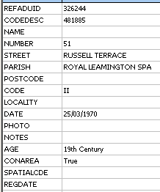
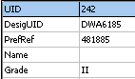
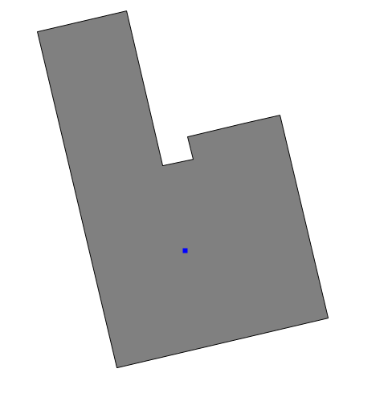
HER
LPA
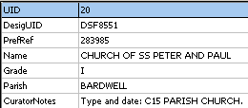
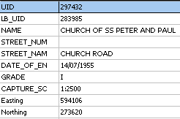
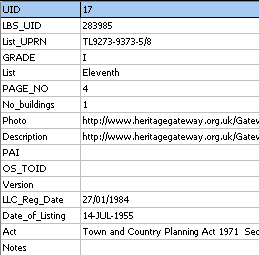
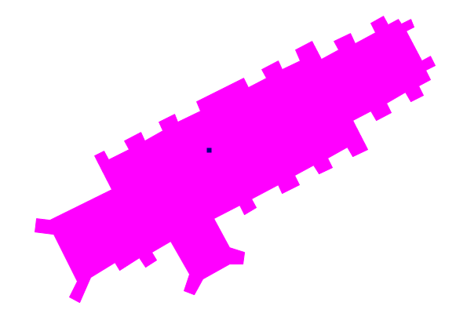
EH

Figure 6 - Default GI Output from LPA, HER and EH

Data Validation Tools

Purpose
This section will cover the evaluation of existing tools that can be used to check the conformance of the Heritage Asset data. Consideration will be given to the syntax (encoding) and semantics (meaning) of the data. 'Levels of Compliance' have already been drafted as part of the English Heritage Data Standard, in the form of the MIDAS Heritage Compliance profile.

List of Data Validation Tools
Overview of Data Validation Tools, key strengths and weaknesses itemised.
- XML Schema
- FISH Data Validation Tool
- Radius Studio

Methodology
Data used to record Heritage Assets is managed in multiple systems that hold data in multiple formats. Validation Rules exist that describe mandatory elements that must exist in records. In some cases, validation rules also exist to determine how certain elements must match standard terminology referred to as INSCRIPTION [23], which comprises a collection of ‘wordlists’ maintained by FISH.
The following levels have been considered when evaluating each of the validation tools
- Level 1 - Check XML Data
- Level 2 - Check MIDAS Heritage UK Historic Environment Data Standard Rules
- Level 3 - Check different grades of conformance
- Level 4 - Check GIS Data

XML Validation

Tool Description
XML validation is a process of checking if any XML document is ‘well-formed’ in that it obeys the general syntax rules of XML and ‘valid’ in that it conforms to the structure defined in its XML Schema (XSD) or Document Type Definition (DTD) document. Numerous tools are freely available on-line to perform these types of checks. Alternatively, commercial products (such as XML Spy) also provide these functions.

Detailed Evaluation
Apparent Strengths
- Level 2 Compliance.
- Currently available.
- XML Schema specifies how to formally describe the elements in an XML document. This description can be used to verify that each item of content in a document adheres to the description of the element in which the content is to be placed. This is strongly tied into concepts involved in XML document validation and parsing.
- Many tools exist for parsing and editing XML Schema, although these generally require significant prior knowledge of the XML Schema syntax. Some aspects of data modelling, such as references and inheritance trees, are particularly complex when modelled with XML schema and are not well supported by tools.
- A ‘well-formed’ check confirms whether the XML document follows the basic syntactic rules of XML.
- A ‘valid’ check can also be performed, where rules dictated in the XML Schema can be used to evaluate the conformance of the data.
Apparent Weaknesses
- Only data in the XML format can be validated.
- Although this technique is capable of checking MIDAS Heritage UK Historic Environment Data Standard rules to see if data is ‘valid’, it is completely reliant on the XML Schema containing those rules. The Section Existing Schemas shows that this is not the current situation for the XML Schema, meaning that only Level 1 compliance is currently achievable.
References
- http://en.wikipedia.org/wiki/XML_validation
- http://www.w3schools.com/xml/xml_validator.asp

FISH Data Validation Tool

Tool Description
Details of the FISH Data Validation Tool can be found on-line on the FISH Interoperability website. The online application validates the content of MIDASXML files. The XML data can be supplied as a file, URL or as simple text that you can cut and paste into the tools interface.

Detailed Evaluation
Apparent Strengths
- Level 3 Compliance (partial).
- Currently available.
- Checks the presence or absence of data required by standards such as the English HER Level 1 Benchmark.
- Verifies the compliance to terminology standards issued by FISH in the INSCRIPTION standard.
- Reports are issued on the compliance of each entry to the relevant standards.
- Additional Validation Rules and Rule Sets can be included.
Apparent Weaknesses
- Only data in the MIDASXML format can be validated.
- Sample MIDASXML data files are available from the FISH Interoperability Toolkit site [24], but they do not validate correctly, and are therefore not ideal exemplar XML documents. For example, the results from validating the example monument file can be seen in Figure 7 - Data Validation Tool Results from monument_example.xml.
- 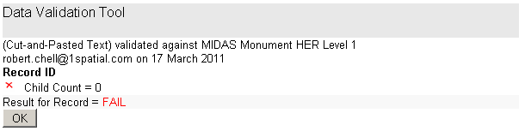
Figure 7 - Data Validation Tool Results from monument_example.xml
- Although there is evidence that Rule Sets can be managed, and Levels of Conformance can be reported, the currently supported version only supports a single benchmark level. It is acknowledged that this is currently being extended as part of the FISH Interoperability Toolkit Revision and Extension Project.
- The toolkit is advertised as checking data compliance against the English HER Level 1 Benchmark. However, on inspection of the Validation Reports, it was observed that -
  - Some values defined as ‘mandatory’ in the data standard were not checked. Note, Table 6 - FISH Validation Toolkit Checks displays what is currently missing.
  - The Map Depiction Information Group was checked, even though this is not a mandatory Information Group for Monument.
Information Group | Unit of Information | Checked
Monument | Primary Reference Number | ✓
Monument | Primary Reference Number Type | ✗
Monument | Description | ✗
Monument | Date of Compilation | ✓
Monument | Date of Last Update | ✓
Monument | Compiler (Organisation) | ✓
Monument | Monument Type | ✓
Date and Period | Primary Reference Number | ✓
Date and Period | Primary Reference Number Type | ✗
Date and Period | Start Date | ✓
Date and Period | End Date | ✓
Location | Primary Reference Number | ✓
Location | Primary Reference Number Type | ✗
Location | Administrative Area Name | ✓
Location | Administrative Area Type | ✓
Location | Grid Reference | ✓
Map Depiction | Primary Reference Number | ✓
Map Depiction | Primary Reference Number Type | ✗
Map Depiction | Positional Accuracy | ✗
Map Depiction | Spatial Feature Type | ✓
Map Depiction | X Coordinate | ✓
Map Depiction | Y Coordinate | ✓
Table 6 - FISH Validation Toolkit Checks
- The validation report comprises a simple list of each record’s compliance (see Figure 8 - FISH Data Validation Tool Output) and contains no summary statistics for the overall state of the data in terms of conformance.
- The tool currently validates Rule Sets as well as data values, but there is no documentation about what the Rule Sets cover. As a result, all MIDASXML files validated failed all the Rule Set checks (see Figure 8 - FISH Data Validation Tool Output).
- 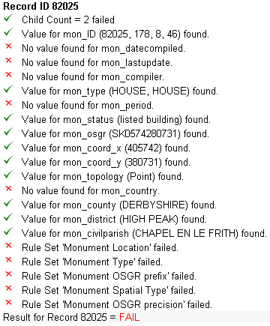
Figure 8 - FISH Data Validation Tool Output
References
- http://www.heritage-standards.org.uk/dvt/docs/index.html
- http://www.heritage-standards.org.uk/dvt/

Radius Studio

Tool Description
Radius Studio, a web-based application, can validate data in a number of different data formats (both GIS and non-GIS formats), and can produce reports that measure this data’s conformance against authored business rules. The application provides a GUI for building these rules, allowing the business users to construct the rules from the MIDAS Heritage UK Historic Environment Data Standard specification.

Detailed Evaluation
Apparent Strengths
- Level 4 Compliance.
- Radius Studio can validate data in XML and popular GIS file formats including MapInfo TAB and ESRI Shapefiles.
- Validation rules are easily authored and deployed into the data validation environment.
- Once authored, validation rules can be used to check the conformance of different sources.
- The Validation Tool provides both a summary of conformance for the entire dataset, and gives the user flexibility to categorise the detailed, record-level conformance reports based on the Validation Rule, or sets of rules (see Figure 9 - Radius Studio Validation Reporting Interface).
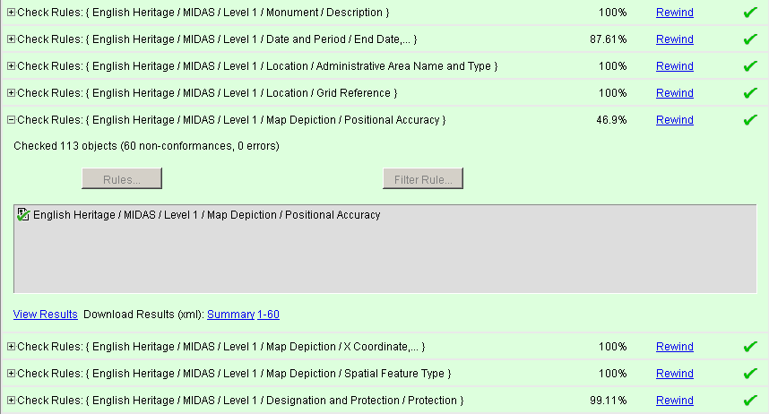
Figure 9 - Radius Studio Validation Reporting Interface
Apparent Weaknesses
- Specific MIDAS Heritage UK Historic Environment Data Standard validation rules need to be authored and tested using the standard’s specification (examples can be seen in Demonstrator).
- There is no current Radius Studio deployment available to the HER, EH or LPA community.
References
- http://www.1spatial.com/pdf/RadiusStudio_Brochure.pdf

Summary and Conclusions
All the validation tools provide useful resources for managers of Heritage Assets to check the conformance of their MIDASXML documents. The first stage is to ensure that the document is a valid XML document.
The second stage is to ensure that the document references valid standard terminology where necessary. This could be achieved by designing the XML schemas correctly. However the current XML Schema for MIDAS XML is not designed to do this. Therefore the FISH Data Validation Tool has a role in performing this second level of validation.
To ensure that the data is fit-for-purpose, additional validation rules will be required to compare the data between documents. These rules can help assist in ensuring
- “we know what historic environment data we have so we can avoid duplicating it”
- “we use common reference data so we know we are talking about the same historic environment records and data”
This is where a Business Rules Management System is required, such as Radius Studio. It allows users to really compare and contrast multiple documents from multiple data sources against a common set of rules and terminology.
Examples of why the Business Rules Management System approach is important will be explored in the following section (Data Compliance).

Data Compliance

Purpose
Assess the current status about the level of compliance of the heritage data against the MIDAS Heritage UK Historic Environment Data Standard using the MIDAS Heritage Compliance profile, and identify what is needed (if applicable) to be done to improve the quality of the data. It is already acknowledged that useful data captured in the Planning System is not currently being made available.

List of Sample Data
To meet the scope of the project sample historic environment information was obtained from a range of sources and styles, all of which were output from the current systems, using known practices. This covered data held and maintained by HERs, required to support HPR planning processes within Local Authorities and data maintained in LPA Planning Systems. In making the assessment of compliance, the sample data covers both textual information and spatial information.
The sample data –
- MIDAS Heritage XML from HER Systems
- MIDAS Heritage XML from English Heritage Listed Building System
- GIS from LPA
- GIS from HER
- Bespoke XML from HER

Methodology
The data was analysed using the three data validation tools describe in the section List of Data Validation Tools. The following checks were made to test the various sample datasets against the English HER Level 1 Benchmark.
- Where the data was in an XML format, it was analysed to see if it was ‘well-formed’ and ‘valid’.
- The FISH Data Validation Tool was then used to check the data for content and matches to standard terminology.
- Radius Studio was then used to confirm the results from the FISH Data Validation Tool, and validate the mandatory Information Groups and Units of Information that were not covered by the FISH Data Validation Tool.

Compliance Matrix
The compliance matrix (Table 7 - Data Compliance Matrix) was compiled by analysing each of the validation rules against each sample dataset, and then by taking an average score. If the average score was less than 50%, then non-compliance was recorded.
A full list of the sample data and its percentage compliance can be viewed in the annex Data Compliance Level.
Information Group | HER MIDAS XML | EH MIDAS XML | HER GIS | LPA GIS | HER bespoke XML
Well-formed Document | ✓ | ✓ |  |  | ✓
Valid Document | ✗ | ✗ |  |  | ✗
Monument | ✓ | ✗ | ✗ | ✗ | ✗
Date and Period | ✓ | ✓ | ✗ | ✗ | ✓
Location | ✓ | ✓ | ✓ | ✓ | ✗
Map Depiction | ✗ | ✓ | ✓ | ✓ | ✓
Table 7 - Data Compliance Matrix

MIDAS Heritage XML from HER Systems

Dataset Description
All the MIDAS Heritage XML files were exported from the existing HBSMR systems. This is the most popular HER system used to manage the HER assets. Data was easily exported in this format by saving information into a report and selecting the MIDAS Heritage XML output as the file type.
Table 8 - MIDAS Heritage XML from HER - Compliance shows how the actual XML Files that are shared with the LPA and EH map against the MIDAS Heritage UK Historic Environment Data Standard.
Information Group | Unit of Information | HER MIDAS XML 1 | HER MIDAS XML 2 | HER MIDAS XML 3 | HER MIDAS XML 4
N/A | Well-formed XML | Y | Y | Y | Y
N/A | Valid XML | N | N | N | N
Monument | Primary Reference Number | 100 | 100 | 100 | 100
Monument | Description | 100 | 100 | 100 | 100
Monument | Date of Compilation | 100 | 100 | 100 | 0
Monument | Date of Last Update | 89 | 100 | 100 | 100
Monument | Compiler (Organisation) | 100 | 100 | 100 | 100
Monument | Monument Type | 99 | 100 | 100 | 100
Date and Period | Start Date | 87 | 100 | 100 | 100
Date and Period | End Date | 87 | 100 | 100 | 100
Location | Administrative Area Name | 100 | 97 | 100 | 100
Location | Administrative Area Type | 100 | 97 | 100 | 100
Location | Grid Reference | 100 | 100 | 100 | 100
Map Depiction | Positional Accuracy | 47 | 57 | 16 | 2
Map Depiction | Spatial Feature Type | 100 | 100 | 100 | 100
Map Depiction | X Coordinate | 100 | 100 | 100 | 100
Map Depiction | Y Coordinate | 100 | 100 | 100 | 100
Table 8 - MIDAS Heritage XML from HER - Compliance

Detailed Evaluation
Apparent Strengths
- These documents were well-formed XML documents.
- Only the Positional Accuracy Unit of Information from the Map Depiction Information Group caused this Information Group to fail compliance. This value was sometimes present in the sample data, suggesting it is an issue with the data capture procedure rather than the technology or standards in use.
- Additional, non-mandatory data for Information Groups such as Designation and Protection.
- Additional, non-mandatory data for Units of Information, in particular for optional values for the Map Depiction Information Group (e.g. precision).
Apparent Weaknesses
- The data exported from the HER did not reference the current version of the MIDAS specification. This was true in all sample data provided. You can see that the previous version (1.0) is referenced by looking at the attribute in Figure 10 - HER MIDAS Document Header, where the element with the xsi prefix allows the document to tie to its W3C XML schema.
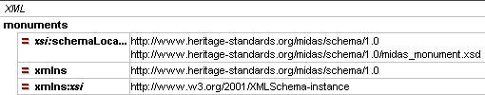
Figure 10 - HER MIDAS Document Header

MIDAS Heritage XML from English Heritage Listed Building System

Dataset Description
This data was taken from the sample output from English Heritage. This data has already been described in the section English Heritage Listed Building System to MIDAS XML.
Table 9 - MIDAS Heritage XML from EH - Compliance shows how the actual XML data that is shared with the HER and LPA maps against the MIDAS Heritage UK Historic Environment Data Standard.
Information Group | Unit of Information | EH MIDAS XML
N/A | Well-formed XML | Y
N/A | Valid XML | N
Monument | Primary Reference Number | 100
Monument | Description | 100
Monument | Date of Compilation | 0
Monument | Date of Last Update | 0
Monument | Compiler (Organisation) | 100
Monument | Monument Type | 100
Date and Period | Start Date | 100
Date and Period | End Date | 100
Location | Administrative Area Name | 100
Location | Administrative Area Type | 100
Location | Grid Reference | 100
Map Depiction | Positional Accuracy | 100
Map Depiction | Spatial Feature Type | 100
Map Depiction | X Coordinate | 100
Map Depiction | Y Coordinate | 100
Table 9 - MIDAS Heritage XML from EH - Compliance

Detailed Evaluation
Apparent Strengths
- This document was a well-formed XML document.
- Additional non-mandatory data for Information Groups such as Designation and Protection.
- Additional non-mandatory data for Units of Information, in particular for optional values for the Map Depiction Information Group (e.g. precision).
Apparent Weaknesses
- Date of Compilation and Date of Last Update Units of Information from the Monument Information Group caused this Information Group to fail compliance. Because this information was missing 100% of the time, it suggests that the export routine (developed in PL/SQL) would need to be updated.

GIS from LPA

Dataset Description
This data was taken from exports from the two most popular Planning Systems by the responsible Planning Officer.
Table 10 - GIS File from LPA - Compliance shows how the actual GIS Files that are shared with the LPA and EH map against the MIDAS Heritage UK Historic Environment Data Standard.
Information Group | Unit of Information | LPA GIS 1 | LPA GIS 2
Monument | Primary Reference Number | 100 | 100
Monument | Description | 100 | 100
Monument | Date of Compilation | 100 | 100
Monument | Date of Last Update | 0 | 0
Monument | Compiler (Organisation) | 100 | 100
Monument | Monument Type | 100 | 100
Date and Period | Start Date | 97 | 0
Date and Period | End Date | 97 | 0
Location | Administrative Area Name | 100 | 100
Location | Administrative Area Type | 100 | 100
Location | Grid Reference | 100 | 100
Map Depiction | Positional Accuracy | 100 | 100
Map Depiction | Spatial Feature Type | 100 | 100
Map Depiction | X Coordinate | 100 | 100
Map Depiction | Y Coordinate | 100 | 100
Table 10 - GIS File from LPA - Compliance

Detailed Evaluation
Apparent Strengths
- Only Date of Last Update Unit of Information from the Monument Information Group caused this Information Group to fail compliance.
- Additional Information detailing how the Heritage Assets are related to External Information Systems – such as the NLPG and Ordnance Survey MasterMap.
Apparent Weaknesses
- The Start Date and End Date Units of Information from the Date and Period Information Group caused this Information Group to fail compliance. Because this information was missing 100% of the time, it is assumed that this type of information is not maintained by the LPA System.

GIS from HER

Dataset Description
This data was taken from exports from the HER Systems by the HERO.
Table 11 - GIS File from HER - Compliance shows how the actual GIS Files that are shared with the LPA map against the MIDAS Heritage UK Historic Environment Data Standard.
Information Group | Unit of Information | HER GIS 1 | HER GIS 2 | HER GIS 3
Monument | Primary Reference Number | 100 | 100 | 100
Monument | Description | 100 | 0 | 0
Monument | Date of Compilation | 0 | 0 | 0
Monument | Date of Last Update | 0 | 0 | 0
Monument | Compiler (Organisation) | 0 | 0 | 0
Monument | Monument Type | 0 | 0 | 100
Date and Period | Start Date | 100 | 0 | 100
Date and Period | End Date | 100 | 0 | 100
Location | Administrative Area Name | 0 | 0 | 0
Location | Administrative Area Type | 0 | 0 | 0
Location | Grid Reference | 100 | 100 | 100
Map Depiction | Positional Accuracy | 0 | 0 | 0
Map Depiction | Spatial Feature Type | 100 | 100 | 100
Map Depiction | X Coordinate | 100 | 100 | 100
Map Depiction | Y Coordinate | 100 | 100 | 100
Table 11 - GIS File from HER - Compliance

Detailed Evaluation
Apparent Strengths
- Although there is currently very little information exported (by default) from the HER, it was noted that the amount of information exported can be easily controlled.
- The GIS format could be manipulated to derive the Units of Information associated with the Map Depiction Information Group.
Apparent Weaknesses
- The exported data does not comply with the English HER Level 1 Benchmark.

Bespoke XML from bespoke HER

Dataset Description
This data was taken from an export from a bespoke HER System by the HERO.
Table 12 - Bespoke XML from HER - Compliance shows how the actual XL data that is shared with the LPA and EH map against the MIDAS Heritage UK Historic Environment Data Standard.
Information Group | Unit of Information | HER Bespoke XML
N/A | Well-formed XML | N
N/A | Valid XML | N
Monument | Primary Reference Number | 100
Monument | Description | 0
Monument | Date of Compilation | 0
Monument | Date of Last Update | 0
Monument | Compiler (Organisation) | 100
Monument | Monument Type | 100
Date and Period | Start Date | 100
Date and Period | End Date | 100
Location | Administrative Area Name | 0
Location | Administrative Area Type | 0
Location | Grid Reference | 0
Map Depiction | Positional Accuracy | 100
Map Depiction | Spatial Feature Type | 100
Map Depiction | X Coordinate | 100
Map Depiction | Y Coordinate | 100
Table 12 - Bespoke XML from HER - Compliance

Detailed Evaluation
Apparent Strengths
- Only Date of Last Update Unit of Information from the Monument Information Group caused this Information Group to fail compliance.
- Additional Information detailing how the Heritage Assets are related to External Information Systems – such as the NLPG and Ordnance Survey MasterMap.
Apparent Weaknesses
- This document was not a well-formed XML document.
- All mandatory Units of Information for the Information Group Location were missing. This suggests that the routines used to export the data have not met the MIDAS Heritage UK Historic Environment Data Standard.

Summary and Conclusions
When comparing the data from the various systems, all appear to maintain a high level of compliance against the English HER Level 1 Benchmark, with the exception of the GIS File exported from the HER. This was surprising as it is the common format pass information from the HER to the LPA.
It was understandable that the Start Date and End Date Units of Information from the Date and Period Information Group were identified as missing in the LPA GIS files. This information was not available in the data available for can download from the EH website (see Figure 6 - Default GI Output from LPA, HER and EH). In many cases, this acted as an initial source Heritage Asset information for the HER.
Comparing the GIS Layers from the HER and those of the LPA also provided interesting results. In many instances, the LPA would look to generate a polygon for the Heritage Asset. Figure 11 - HER and LPA Data, showing Primary Reference Number shows how the HER point record is usually recorded inside the LPA polygon record. However, there are some differences where the point is just outside the polygon and others where they are 100s of metres apart. You can see the difference in location between the features whose Primary Reference Number is 284023 in Figure 11 - HER and LPA Data, showing Primary Reference Number. Validation Rules showed that only 76% of HER points were contained inside its corresponding LPA Polygon.
This is an area that should be improved, and it was even supported by the observations at the workshops. The LPA often commented that they would like a little more information about the HER records that they were supplied. In some cases, this feedback was acted on by the HERO, but it was not standard practice.
In other instances the HER point record will refer to a selection of properties. In this instance, the LPA often creates a set of polygons, each being a distinct record in the LPA system, but which all reference the same Primary Reference Number. This is shown in Figure 12 - HER and LPA Data, showing House Numbers, where you can see the HER point record for houses numbered 5-13, and the LPA polygon records, where an individual polygon is created for houses 5, 7, 9, 11 and 13.
There was varied opinion amongst the workshops about whether the location of the HER data should be converted to a polygon, or remain as a point feature. Even if the decision is to make use of the LPA Polygon, they must be examined. Validation Rules were put in place to test the sample LPA Polygons and check for their consistency. Tests revealed that in some scenarios, 17% of the data contained geographical glitches (spikes, small holes and duplicated points), those usually associated with digitsing errors. Examples of these can be seen in Figure 13 - LPA Polygons containing Spikes.
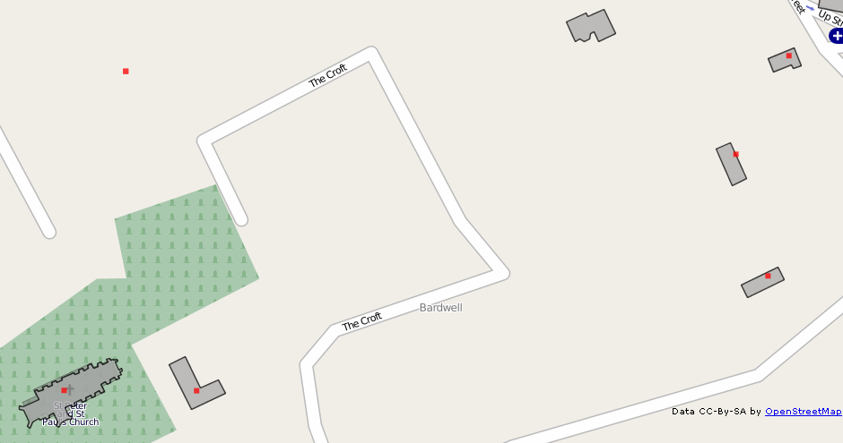
248023
248023
Figure 11 - HER and LPA Data, showing Primary Reference Number

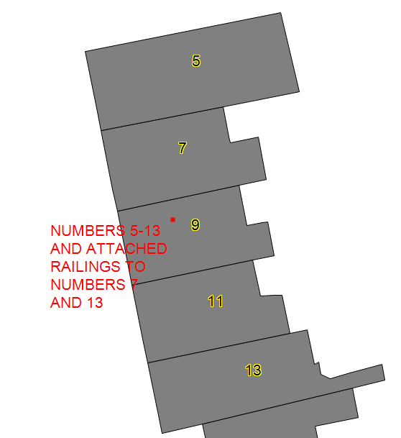
KEY
HER Point
LPA Polygon
Figure 12 - HER and LPA Data, showing House Numbers

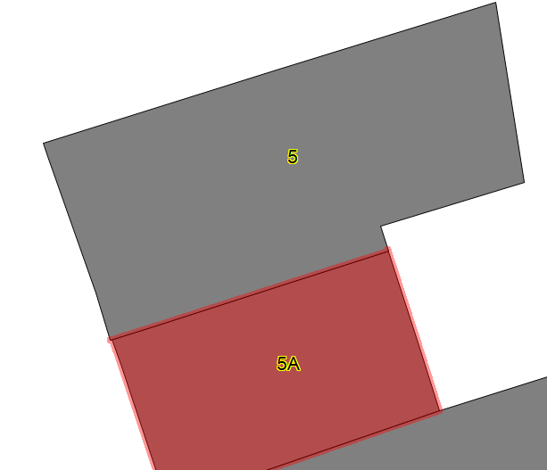


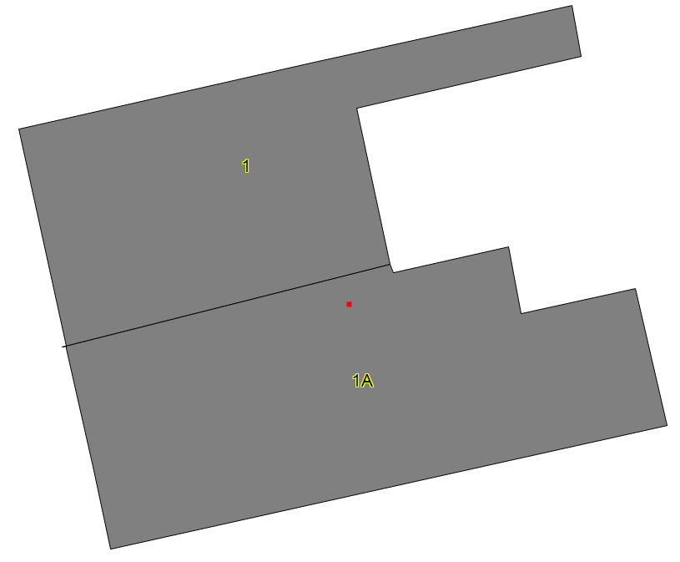

Figure 13 - LPA Polygons containing Spikes

Demonstrator
The demonstrator provides three important roles in this analysis. It allows the recommendations arising from the analysis to be evaluated in a worked example which can help to mitigate the risk of incomplete analysis acquired through human interpretation. It also provides the ability to demonstrate to the audience what is actually technically feasible. Practical considerations were one of the key objectives for this project – see Objectives. Finally, it shows how full interoperability can be achieved, i.e. information flows to and from both LPA Planning Systems and HERs.

Requirements
The demonstrator provides an understanding of how the analysis was undertaken. All the data used in this demonstrator is provided by the LPAs and HEROs who participated in the workshops.
The demonstrator was required to provide evidence of the following activities that were conducted as part of this in the project -
- Data Mapping to MIDAS Heritage
  - HER data
  - LPA data
- Data Validation Tools
  - XML Schema
  - FISH Data Validation Tool
  - Radius Studio
- Data Compliance
  - HER MIDAS Heritage data quality assessment
  - LPA GIS data quality assessment
  - HER GIS data quality assessment
  - HER data quality assessment
- Data Improvement
  - Alert Map Production
  - LPA Conflation with HER
- Data Delivery
  - Web Map Service
  - Desktop GIS Delivery

Future Vision and Recommendations
In order to align with HPR, there is a need to raise the awareness and increase the importance of the HER. Its value is not currently perceived or well understood, especially with regard to Planning. At the same time, it must be acknowledged that the ownership of the HER should reside with the HERO. The HERO has a unique skill set and role to play in Planning. Their skills in interpreting information relating to the Historic Environment, and then providing advice to the LPA, are not easily automated or transferred. They provide professional judgement, not detailed quantification.
Based on these simple observations, the HERO must become the gatekeeper of Heritage Asset information for the heritage world. This will require a change in mind-sets. Some HEROs have already acknowledged this and it should become the vision for the future. It will be important to reference information from the HER 21 Project 6032 The Historic Environment Officer Managing an HPR Compliant HER.
To improve interoperability data duplication must be addressed. This can help remove current confusion surrounding multiple sources of similar information, establish a primary source for information on the Historic Environment, and let the HERO use that source to provide their valuable advice. The source of data can also be used to proactively produce information, rather than just providing information when Planning Officers ask for it. If this is successful, LPAs can be encouraged to stop maintaining local copies of Heritage Assets, which they currently develop in isolation.
The mission statement for the HER must be to become the primary source of information on the Historic Environment and to proactively produce information.
To improve interoperability the following four recommendations should be considered when developing the strategic goals and action plans for the HPR programme.
Recommendation 1 – MIDAS Heritage House-Keeping
Recommendation 2 – Access to Unified Data Set of National Heritage Asset Data
Recommendation 3 – Integration with the Planning Portal
Recommendation 4 – Data Improvement Programme
Key components required by each recommendation have been considered based on 1Spatial’s experience in performing similar tasks. It is recognised that some components may already exist and be available to English Heritage. The costed options are only estimates aimed to give English Heritage guidance on the rough order of magnitude about what key elements would be required to move forward on the recommendations.
1Spatial is highly experienced in successfully managing critical and high profile projects. Iterative methodologies best support the ability to deliver successful projects on time, to budget, and to the agreed scope/specification. 1Spatial use an adapted IBM Rational Unified Process for development work, with PRINCE2 and/or AGILE for project management. The Inception and Elaboration phases in this approach would support the realisation of accurate requirements and costs to deliver against the recommendations.
These recommendations will also help move English Heritage towards Linked Data. Linked Data is about using the Web to connect related data that wasn't previously linked [25], which is effectively what the below process is facilitating. Understanding how the primary sources of information on the Historic Environment are ‘linked’, not only to themselves, but to Planning Decisions could rapidly be published on the Web in a machine-readable way. This may even be further expanded to deliver data to meet the INSPIRE directive [20].
Recommendation 1 – MIDAS Heritage House-Keeping
The MIDAS schema has a number of features that could be improved upon to make it more succinct, internally consistent and useful as a component of an interoperable solution (such as one using web services to join disparate systems).
There is a need for inclusion of a recognised metadata standard. The MIDAS Heritage UK Historic Environment Data Standard does state that it is intended to complement recognised standards, such as UK GEMINI 2. This should be incorporated into the MIDAS Heritage schemas.
MIDAS should look to take advantage of other common standards, including those currently adopted by 1APP. These include taking advantage of location and place information defined in the current standards BS7666 and GML Schema. Particular reference should be given to HER21 Project 6034 - Development of GIS Data Standards for Use in HERs in England, and also to the use of GML in INSPIRE. GML Schema and BS7666 are also standards already adopted and common the planning practice.
Finally, for the standard to have the opportunity to engage with and serve the business workflow rather than being a static document, the schemas should be modified to support data lifecycle events, so that an indication of the quality or status of items of information can be recorded.
This development work should take place in collaboration with FISH, and should ensure that the schema that is produced is compatible with existing Web Feature Server implementations and client tools. Estimates for the associated development can be found in Table 13 - Recommendation 1: Costed Options.
Development Component | Effort (Days)
Schema Development | 30 days
Table 13 - Recommendation 1: Costed Options
Recommendation 2 – Access to Unified Data Set of National Heritage Asset Data
A central service should be developed to disseminate a national set of Heritage Asset information. This is an essential building block to address the issue of data duplication. This service may form a natural extension to the existing Heritage Gateway, and the new services available can act as a pull factor to encourage all HEROs to subscribe.
The centralised service can control what data is disseminated to which user groups. The first main dataset that can be delivered through the service is the Archaeological Alert Map. Alert Maps should be made available as a national set of data, permanently accessible, and produced from an agreed set of rules so that data being added to the service is quality controlled. These Alert Maps can then be used by LPAs for prioritising and managing Planning Applications. Particular reference should be given to HER21 Project 6033 - HER-Derived Alert and Constraint Mapping Supplied to Local Authorities.
It is not critical that all HERs adopt the Alert Maps at the same time, and the National Alert Map can grow organically as more HERs are brought on-line. The more HERs that contribute, the more valuable the data source and services that uses it.
A Business Rules Management System would be required to combine geographical analysis and mapping of controlled vocabularies to build the Alert Maps. It will be important for the Business Rules Management System to make use of flexible data models and semantics as well as the syntactic nature of the data. Careful consideration will need to be given to the Rules to cover National, Regional and Local scenarios in order to produce these Alert Maps.
The successful service can encourage the LPAs to stop managing their own copies of the Heritage Asset data. This results in a reduction in the amount of duplicated data and the removal of the burden and expense incurred by the LPA to manage this information. With the enhanced emphasis on pre-applications, a consistent view and use of the Alert Map will also help reduce the extent to which different advice is given by the HERO and LPA.
This should be developed in collaboration with English Heritage and may lead to the formation of an HER working-group to provide guidance on Business Rule support for Quality Assurance and Alert Map production. Estimates for the Software, Hardware and associated Development can be found in Table 14 - Recommendation 2: Costed Options.
Software and Hardware Component | Cost (£)
Server - Hardware | £8,000
Relational Database Management System (e.g. Oracle*) | £20,000
Business Rules Management System (e.g. Radius Studio) | £25,000
Server – Software for publishing data (e.g. GeoServer) | £0 - Open Source
Server – Software for hosting applications (e.g. JBoss) | £0 - Open Source
Development Component | Effort (Days)
Quality controlled MIDAS Upload Service | 40 days
WMS Configuration | 5 days
Business Rules Development for Data Quality Assurance | 10 days
Business Rules Development for Alert Map Production | 10 days
Table 14 - Recommendation 2: Costed Options
* The Oracle pricing is based on an Oracle Standard Edition One license. PostGIS (and Open Source alternative) support maybe possible from but would result in an additional cost to the Business Rules Management System component.
Recommendation 3 – Integration with the Planning Portal
The Heritage Gateway should integrate more closely with the Planning Portal to provide better information to the HERO to support them in providing advice to the LPAs. This can empower the HERO to become more closely integrated into the consultative process.
The Alert Map can be combined with the Planning Portal Weekly Lists, and used to push information to the HERO. This will remove the reliance on LPA to provide Weekly Lists, and push this information, with Alert Map prioritisation, to the HERO. This could be used by Software Vendors to generate consultation records for the HERO, so that they can dramatically improve the efficiency with which they work. Both the LPAs and HERs have consultation modules in their systems, and efficiencies could be gained by making use of them. Even the potential completion of consultation’s on-line would lead to greater efficiencies.
Opening up of data gives the LPA access, but the integration of the Heritage Gateway and the Planning Portal means that the HERO has control over the provision of timely expert advice, so that the risk of the LPA using the newly available data to bypass this task is mitigated.
This should be developed in collaboration with English Heritage and the Planning Portal. The first phase of this should construct a prototype to ensure that integration between the two portals is possible and an off-line augmented report can be produced. Once this has been achieved, a costed estimate could be produced for production implementation. Estimates for the associated development of this prototype can be found in Table 15 - Recommendation 3: Costed Options.
Development Component | Effort (Days)
Planning Portal Prototype Integration | 15 days
Table 15 - Recommendation 3: Costed Options
Recommendation 4 – Data Improvement Programme
The HER data can be improved by augmenting it with the LPA Heritage Data. This can drive an improved set of information to the HER, and also improve the accuracy and currency of all data delivered by the Heritage Gateway. This provides a compelling business case for the LPA to keep the HERO informed on Heritage Asset updates, because the data will be used directly to deliver the Alert Maps that are fundamental to the efficient delivery of HERO advice as part of the Planning process.
MIDAS Heritage can be used to deploy quality control processes around this programme. The link to external systems contained in the LPA data should be migrated into the HER to improve its potential to be linked to other External Information Systems. This will increase the potential for English Heritage to provide more linkages to its data, and publish this as Linked Data.
This should be developed in collaboration with English Heritage and may lead to the formation of an HER working-group to provide guidance on Business Rule support for Quality Improvement processes. Estimates for the software and associated development for this can be found in Table 15 - Recommendation 3: Costed Options.
Software Component | Cost (£)
Business Rules Management System | £10,000*
Development Component | Effort (Days)
Business Rule Implementation for Data Improvement | 30 days
Table 16 - Recommendation 4: Costed Options
* The Business Rules Management System component can be extended by only purchasing additional nodes to support increased demands, making it more cost-effective than purchasing a completely new software license.

Tools and Applications - On-line Vendor Survey
The introductory text and questions used to conduct the survey of existing Tools and Applications, from the vendors’ perspective are recorded as a PDF document that supports this report -HERvendorSURVEY.pdf.

Tools and Applications - On-line User Survey
The introductory text and questions used to conduct the survey of existing Tools and Applications, from the users’ perspective are recorded as a PDF document that supports this report -HERuserSURVEY.pdf.

User Workshops
Here follows the introductory text and questions used to conduct the workshops of existing data model transformation tools, from the users' perspective.
Note that all the workshop participants completed the On-Line User Survey (see Tools and Applications - On-line User Survey).
Introductory Text
Thank you for taking the time to complete the recent on-line survey that was posted on the HER Forum. The project is really aimed at trying to explore the degree to which Local Authority electronic planning systems have the potential to be interoperable with HERs.
The assessment day is aimed at gaining an understanding about how you use your systems and historic environment data. It is aimed at trying to understand how the planners who use the electronic planning systems then use the historic data that is maintained by the HER.
This important project should allow the whole sector to provide feedback with guidance on the integration of HERs with wider planning process, and establish standards for future HER development.
Assessment Day Agenda
- Project Overview (Background, Scope, Work so far, Survey Results Preview, Report Design)
- Overview of historic records held by the LPA
- Overview of Electronic Planning System used
- Overview of functionality in Electronic Planning System as it relates to provision of historical records
- Overview of workflow – how are records captured, stored, maintained, spatially referenced
- Overview of specific critical processes and data capture & management for:
  - Listed Building Designation
  - Listed Building Consent
  - Scheduled Monument Designation
  - Scheduled Monument Consent
  - Conservation Area Consent
  - Assets covered by material consideration
  - Assets covered by Hedgerow Regulations
- Overview of record management – how are records updated, versioned, quality assessed, quality assured, transaction history recorded, linked information referenced, etc.
- Overview of how historical records are found, accessed, used by internal and external users
- Overview of how external historical records are found, accessed, etc.
- Overview of metadata structure, capture, storage, provision
- Provision of sample data for Detailed Analysis

Schema Transformation Tools
This section investigates the practicalities of implementing transformation services using existing transformation tools. Investigation of the capabilities of existing tools helps to validate the practicality of requirements defined in the implementing rules and also helps identify possible constraints that may need to be considered in the technical guidance, to ensure that the transformation services can be implemented by multiple vendors.
The format of this section is as follows: -
- The list of identified transformation tools
- Outline of the methodology used to select which tools were evaluated, and the criteria which were applied
- Detailed evaluation of each of the evaluated tools.
Evaluation Criteria
To aid discussions on transformation functionality, a number of capability levels were defined. These describe different types of functionality that may be required in order to transform schema of varying complexity. When the source schema is closely aligned to the target schema, a lower level of transformation functionality is required. Each level incorporates all functionality from earlier levels, i.e. if a transformation service supports functionality in level n, it should also support all functionality in level n–1.
- Level 1 - Renaming classes and attributes.
- Level 2 - Simple attribute derivation.
- Level 3 - Aggregating input records.
- Level 4 - Complex derivation and dynamic type selection.
- Level 5 - Deriving values based on multiple features.
- Level 6 - Conflation and model generalisation
These levels are described in more detail in Appendix B.

XtraServer
Contact organisation
Interactive Instruments
Version under consideration
Version 3.2
Description
Interactive Instruments' Xtraserver provides Web Feature Server (WFS) and Web Map Server (WMS) implementations. The WFS supports versions 1.0 and 1.1 of the OGC WFS Specification. XtraServer WFS is capable of performing schema transformations to meet all of the six levels of requirement. It uses a proprietary, XML-encoded mapping language which enables complex mapping rules to be refined to cover the required scenarios. In addition, XtraServer supports customisation using SQL to further refine the mapping from the source schema to the target schema.
References
www.interactive-instruments.de/index.php?id=xtraserver&L=1
www.opengeospatial.org/standards/wfs
Evaluation
Participation in tool vendor survey reported the following capabilities:
- Level 1: Basic renaming of attributes and instances - SUPPORTED
- Level 2: Basic derivation - SUPPORTED
- Level 3: Aggregation - SUPPORTED
- Level 4: Complex derivation - SUPPORTED
- Level 5: Multiple derivation - SUPPORTED
- Level 6: Model conflation and generalisation - SUPPORTED
Apparent strengths
- Mappings can be defined using UML
- XtraServer schema mappings, being expressed using XML, are suitable for transmission as parameters to Web services operations
Apparent weaknesses
- Mapping language is proprietary hence it is not possible to exchange mappings with other tools or use mappings developed elsewhere.
- SQL transformations can only be performed in a relational database.

Deegree Web Processing Service
Contact organisation
lat/lon GmbH / University of Bonn Department of Geography, GIS Unit
Version under consideration
Version 2.3

Description
Deegree is a free and open source implementation of OGC and ISO standards concerning Web-based GIS processing. The Deegree distribution includes a Web Processing Service. This provides supporting capability for developer-defined processes. The processes themselves require to be written, in Java, by implementors. A Java class needs to be extended to implement an abstract execute() method which takes a map of input parameters (potentially source and target schema references) and an output definition (which could correspond to a model mapping in the INSPIRE TNS context). Since it uses Java, the WPS can thus perform any kind of processing in principle. It is thus suitable for integration with a transformation technology such as XSLT or any of the model mapping languages discussed in this chapter.
References
http://www.deegree.org/
http://download.deegree.org/deegree2.3/docs/wps/html/deegree_wps_documentation_en.html
Evaluation
Participation in tool vendor survey reported the following capabilities:
- Level 1: Basic renaming of attributes and instances - SUPPORTED
- Level 2: Basic derivation - SUPPORTED
- Level 3: Aggregation - SUPPORTED
- Level 4: Complex derivation - SUPPORTED
- Level 5: Multiple derivation - SUPPORTED
- Level 6: Model conflation and generalisation - SUPPORTED
Note: However, these features would require to be developed as an implementation of the WPS and integrated into the server.
Apparent strengths
- It is possible to implement any form of processing, including schema transformations, using the Java programming language or other technology such as XSLT incorporated programmatically via Java.
Apparent weaknesses
- Development of schema transformations, while possible, requires significant development effort.

FME Server
Contact organisation
Safe Software
Version under consideration
FME 2010 Professional Edition
Description
FME Server is a spatial ETL platform offering flexible spatial data distribution and scalable data loading and conversion. It offers, among other features, server-based spatial translation and transformation services. Its schema mapping language is proprietary. The functionality is made available to users through a graphical user interface. Pluggable transformers offer discrete processing steps and are chainable to form transformation flowlines.
References
www.safe.com/products/server/overview.php
www.safe.com/c/inspire/inspire.php
http://downloads.safe.com/fme/brochures/transformers.pdf
Evaluation
Participation in tool vendor survey reported the following capabilities:
- Level 1: Basic renaming of attributes and instances - SUPPORTED
- Level 2: Basic derivation - SUPPORTED
- Level 3: Aggregation - SUPPORTED
- Level 4: Complex derivation - SUPPORTED
- Level 5: Multiple derivation - SUPPORTED
- Level 6: Model conflation and generalisation - SUPPORTED
Apparent strengths
- FME Server is very flexible and offers extensive data format and transformation support.
- User interface is well-designed and intuitive making it easier for non-programmers to use.
Apparent weaknesses
- Mapping language is proprietary hence it is not possible to exchange mappings with other tools or use mappings developed elsewhere.

GO Publisher
Contact organisation
Snowflake Software
Version under consideration
Version 1.4
Description
Snowflake Software's GO Publisher is a flexible, production standard platform for publishing spatial data. GO Publisher uses Oracle Spatial and XML Schema/XSLT functionality to perform the transformation from source to target schema.
References
http://www.snowflakesoftware.co.uk/markets/inspire/solution.htm
http://www.snowflakesoftware.co.uk/tv/index.htm
Evaluation
Participation in tool vendor survey reported the following capabilities:
- Level 1: Basic renaming of attributes and instances - SUPPORTED
- Level 2: Basic derivation - SUPPORTED
- Level 3: Aggregation - SUPPORTED
- Level 4: Complex derivation - SUPPORTED
- Level 5: Multiple derivation - SUPPORTED
- Level 6: Model conflation and generalisation - NOT SUPPORTED
Apparent strengths
- Graphical user interface enabling transformations to be configured by non-programmers.
- Ability to express source and target schema models using XML Schema syntax and extend transformations using inline XSLT stylesheets.
- Extensive support for spatial data formats including GML 3.
Apparent weaknesses
- Mapping language is proprietary hence it is not possible to exchange mappings with other tools or use mappings developed elsewhere.
- Use of XSD/XSLT as basis for mappings limits the expressiveness of the transformations to that of XSLT itself.

Talend Integration Suite Enterprise Edition
Contact organisation
Talend
Version under consideration
Talend Open Studio v3.2.3
Description
Talend Open Studio, on which Talend Integration Suite is based, is a general purpose ETL (Extract-Transform-Load) platform. Talend also distribute a Spatial Data Integrator based on Open Studio. It is capable of processing several GIS formats including PostGIS, ESRI Shapefile and MapInfo MIF/MID.
References
www.talend.com/products-data-integration/talend-integration-suite.php
www.vividsolutions.com/jts/jtshome.htm
Evaluation
Participation in tool vendor survey reported the following capabilities:
- Level 1: Basic renaming of attributes and instances - SUPPORTED
- Level 2: Basic derivation - SUPPORTED
- Level 3: Aggregation - SUPPORTED
- Level 4: Complex derivation - SUPPORTED
- Level 5: Multiple derivation - SUPPORTED
- Level 6: Model conflation and generalisation - SUPPORTED
Apparent strengths
- Spatial Data Integrator provides the ability to write custom transformations using the Java Topology Suite, which supports two-dimensional simple vector features.
Apparent weaknesses
- Spatial Data Integrator is not able to output GML, hence adapting it for INSPIRE transformations would require significant development effort.

Radius Studio
Contact organisation
1Spatial Group Ltd.
Version under consideration
Version 2.1.0.15
Description
Radius Studio is an enterprise spatial data integration platform that enables users to rapidly analyse scattered geospatial data to assess their quality and content. It does so by allowing users to collaboratively define and apply business rules to measure and maintain geospatial data quality. Radius Studio provides data mining, rules-based conformance checking, data cleaning and re-engineering capabilities that facilitate data transformation and reuse. It is a scalable solution that supports grid processing.
References
www.gsdi.org/gsdiconf/gsdi11/papers/pdf/283.pdf
http://www.1spatial.com/products/#1265028216640_1/5
Evaluation
Participation in tool vendor survey reported the following capabilities:
- Level 1: Basic renaming of attributes and instances - SUPPORTED
- Level 2: Basic derivation - SUPPORTED
- Level 3: Aggregation - SUPPORTED
- Level 4: Complex derivation - SUPPORTED
- Level 5: Multiple derivation - SUPPORTED
- Level 6: Model conflation and generalisation - SUPPORTED
Apparent strengths
- Radius Studio has a collaborative editing graphical user interface for defining rules and actions which can be configured by non-programmers.
- As part of the Radius Studio platform, 1Spatial has developed a dedicated XML grammar to make possible the exchange of mathematically rigorous schema transformation models, based on first-order predicate logic and using an approach that is conceptually similar to SWRL, but with the addition of support for spatial operators. This language is known as SQUIRL (Spatial QUality Integration Rules Language). The language is expressed in XML syntax and is thus portable to other XML-based formats and is Web friendly.
- Radius Studio is inherently scalable and is being used in very demanding service-oriented architectures.
Apparent weaknesses
- Mapping language is proprietary hence it is not possible to exchange mappings with other tools or use mappings developed elsewhere. 1Spatial is contemplating the release of this mapping language as a public standard under the stewardship of the open source community.

General Results Summary
Generalisations of key aspects of the responses to the survey are listed below.
Please note that this is based on the responses provided and is not necessarily an indication of suitability for use within the context of INSPIRE transformation services. Any claims will need to be verified further with tool vendors.
- This survey strengthens the argument that there are no widely used standards for schema description or mapping description, highlighting the importance of this project to achieve interoperability between transformation service implementations. All respondents use some form of proprietary language for schema definition and mapping description.
- Most respondents claimed support for all levels of transformation functionality identified. This is significant since it implies that transformation services should be feasible for the INSPIRE project, with a wide choice of potential tool vendors. Additionally, it permits the technical guidance to select a mapping description language that is sufficiently expressive to describe all schema mappings that are likely to be required. There is no need to simplify the functional requirements of a transformation service (so that it can be implemented more easily), at the expense of being able to use it on a wide variety of source data.
- There is a wide variety of supported input and output data formats. Most tools support GML, Oracle Spatial and ESRI Shape files.
- The mapping definition process varies from intuitive user interfaces to editing structured text files.
- Most tools have optional support for syntactic validation of the schema mapping, to ensure that it meets the rules for the target schema. Few support semantic validation to ensure that the target data is fully compliant with the data specifications.
- Most tools are capable of running in a wide variety of environments, including combinations of Linux, Windows, 32bit and 64bit. Desktop application and batch processes are frequently provided, with some tools providing web accessible interfaces.
- The majority of tools claim support for scalable processing, including processing of multiple simultaneous requests. As a result, it is likely that the performance requirements defined in the implementing rules may be met by many tools.

Data Compliance Level
Here follows the summary of the conformance of the sample MIDAS Heritage data against the MIDAS Heritage UK Historic Environment Data Standard.
Information Group | Unit of Information | HER MIDAS XML 1 | HER MIDAS XML 2 | HER MIDAS XML 3 | HER MIDAS XML 4 | EH MIDAS XML | LPA GIS 1 | LPA GIS 2 | HER Bespoke XML
N/A | Well-formed XML | Y | Y | Y | Y | Y |  |  | N
N/A | Valid XML | N | N | N | N | N |  |  | N
Monument | Primary Reference Number | 100 | 100 | 100 | 100 | 100 | 100 | 100 | 100
 | Description | 100 | 100 | 100 | 100 | 100 | 100 | 100 | 0
 | Date of Compilation | 100 | 100 | 100 | 0 | 0 | 100 | 100 | 0
 | Date of Last Update | 89 | 100 | 100 | 100 | 0 | 0 | 0 | 0
 | Compiler (Organisation) | 100 | 100 | 100 | 100 | 100 | 100 | 100 | 100
 | Monument Type | 99 | 100 | 100 | 100 | 100 | 100 | 100 | 100
Date and Period | Start Date | 87 | 100 | 100 | 100 | 100 | 97 | 0 | 100
 | End Date | 87 | 100 | 100 | 100 | 100 | 97 | 0 | 100
Location | Administrative Area Name | 100 | 97 | 100 | 100 | 100 | 100 | 100 | 0
 | Administrative Area Type | 100 | 97 | 100 | 100 | 100 | 100 | 100 | 0
 | Grid Reference | 100 | 100 | 100 | 100 | 100 | 100 | 100 | 0
Map Depiction | Positional Accuracy | 47 | 57 | 16 | 2 | 100 | 100 | 100 | 100
 | Spatial Feature Type | 100 | 100 | 100 | 100 | 100 | 100 | 100 | 100
 | X Coordinate | 100 | 100 | 100 | 100 | 100 | 100 | 100 | 100
 | Y Coordinate | 100 | 100 | 100 | 100 | 100 | 100 | 100 | 100

Schema Mappings

MIDAS Heritage Data Standard Mapping to MIDAS XML
Information Group: AREA
name | M/O | S/R | Notes | In XSD? | Possible XML element | Gap Analysis
Primary Reference Number | M | S | Identifies this area within the information system. Example: 187965. | PARTIAL | /monuments/monument/appellation/identifier | midas_monument is the only schema suitable for capturing area information. Perhaps there could be a separate midas_area schema for this? See monument worksheet for other comments.
Primary Reference Number Type | M | S | Used to support interoperability. Default value: "area" | PARTIAL | /monuments/monument/appellation/identifier | Could be supported by addition of enumerated attribute defining reference number type (this could be a reference to a list of types defined somewhere in the schema).
Heritage Asset Name | O | R | Identifies this area within the information system. Example: NORTH MOOR PROJECT AREA. | YES | /monuments/monument/appellation/name
Compiler (Organisation) | M | S | Example: ENGLISH HERITAGE | PARTIAL | /monuments/meta/contacts/contact/organisation | Contacts is minOccurs="0", could either be minOccurs="1" or not qualified with cardinality at all. However, this may be unduly restrictive on the metadata schema. It is also not stated what the nature of the contact is, and here the role element could be used, given value 'compiler'. This requires a) role is made mandatory, b) a controlled list of role types is maintained within the schema, which includes the 'compiler' type.
Compiler (Person) | O | S | Example: JAMES O'BRIEN | PARTIAL | /monuments/meta/contacts/contact/name | It is not clear what the nature of the contact is, and here the role element could be used, given value 'compiler'. This requires a) role is made mandatory b) a controlled list of role types is maintained within the schema which includes the 'compiler' type.
Date of Compilation | M | S | Example: 23-FEB-2008 | PARTIAL | /monuments/recordMetadata/created | This information sits logically with the contact information, but there is no suitable data item to contain it. However, recordMetadata can be used, although it is not clear why there is a need for recordMetadata when midas:meta is attached to the list of monuments in the HER. Would be better to amplify the main metadata with creation/update details, as in, e.g. UK GEMINI metadata standard. Also, cardinality is wrong: should not be qualified with minOccurs, as can only be created once and is mandatory.
Date of Last Update | M | S | Example: 14-MAY-2008 | PARTIAL | /monuments/recordMetadata/lastupdated | Same as for /monuments/recordMetadata/created.
Entry Type | O | S | To distinguish Rural, Urban, Seascape, etc. Example: RURAL AREA | PARTIAL | /monuments/monument/characters/character/type | Has maxOccurs="unbounded" whereas should be maxOccurs="1".
External Information System | O | R | Where this area is also documented by another information system. Example: WESTMORLAND HER | NO |  | No element available to use for this. Midas_references provides a way of capturing links to remote documentation sources, but it is not incorporated in any of the other schemas.
External Information System Primary Reference Number | O | R | FY6875 | NO |  | No element available to use for this. Midas_references provides a way of capturing links to remote documentation sources, but it is not incorporated in any of the other schemas.
Description | M | R | Example: Two areas of unimproved grassland/moorland North of Fyfield. The western, larger area centres on Fillborough henge. | PARTIAL |  | Currently, whilst this is a required element, it is maxOccurs="unbounded" but this table says it should be single, implying not qualified as minOccurs or maxOccurs. Possibly also apply an XML assertion* to test that only one of the two 'description' child elements (full or summary) is present (*requires XSD 1.1). NB description/full and description/summary should be qualified as maxOccurs="1".
Description Type | O | R | Example: SUMMARY | PARTIAL |  | No element available to use for this, although the type can be inferred from presence of a full or summary description element.
Area Type | M | R | A general indication of the type of area. Example: MOORLAND | PARTIAL | /monuments/monument/characters/character/type | Is minOccurs="0" whereas should be minOccurs="1". Charcter is minOccurs="0" whereas needs to be mandatory.
Evidence | O | R | Evidence on which the definition of the area is based. Example: DOCUMENTARY EVIDENCE | YES | /monuments/monument/characters/character/type/evidence
Protection Type | O | R | Used where a simple flag to indicate protection is appropriate. For detailed recording, a related Designation and Protection entry should be used.  Example: CONSERVATION AREA | PARTIAL | /monuments/monument/designations/designation/status | Need to repeat the designation element to capture the appropriate behaviour.

Information Group: MONUMENT
name | M/O | S/R | Notes | In XSD? | Possible XML element | Gap Analysis
Primary Reference Number | M | S | Example: 187965 | PARTIAL | /monuments/monument/appellation/identifier | Identifier needs to be made mandatory (i.e. remove minOccurs and maxOccurs).
Primary Reference Number Type | M | S | Used to support interoperability. Default value: “monument” | PARTIAL | /monuments/monument/appellation/identifier | Could be supported by addition of enumerated attribute defining reference number type (this could be a reference to a list of types defined somewhere in the schema).
Heritage Asset Name | O | R | Example: OLD GLOVE FACTORY | YES | /monuments/monument/appellation/name
Description | M | S | Example: Glove factory opened in 1887 to provide work for the… | PARTIAL | /monuments/monument/description | Currently, whilst this is a required element, it is maxOccurs="unbounded" but this table says it should be single, implying not qualified as minOccurs or maxOccurs. Possibly also apply an XML assertion* to test that only one of the two 'description' child elements (full or summary) is present (*requires XSD 1.1). NB description/full and description/summary should be qualified as maxOccurs="1".
Description Type | O | S | Example: FULL | PARTIAL | /monuments/monument/description | No element available to use for this, although the type can be inferred from presence of a full or summary description element.
Compiler (Organisation) | M | S | Example: WESTSHIRE INDUSTRIAL HERITAGE GROUP | PARTIAL | /monuments/meta/contacts/contact/organisation | Contacts is minOccurs="0", should either be minOccurs="1" or not qualified with cardinality at all. However, this is unduly restrictive on the metadata schema. It is also not clear what the nature of the contact is, and here the role element could be used, given value 'compiler'. This requires a) role is made mandatory, b) a controlled list of role types is maintained within the schema, which includes the 'compiler' type.
Compiler (Person) | O | S | Example: JAMES FARRELL | PARTIAL | /monuments/meta/contacts/contact/name | It is not clear what the nature of the contact is, and here the role element could be used, given value 'compiler'. This requires a) role is made mandatory b) a controlled list of role types is maintained within the schema which includes the 'compiler' type.
Date of Compilation | M | S | Example: 23-MAY-2009 | PARTIAL | /monuments/recordMetadata/created | This information sits logically with the contact information, but there is no suitable data item to contain it. However, recordMetadata can be used, although it is not clear why there is a need for recordMetadata when midas:meta is attached to the list of monuments in the HER. Would be better to amplify the main metadata with creation/update details, as in, e.g. UK GEMINI metadata standard. Also, cardinality is wrong: should not be qualified with minOccurs, as can only be created once and is mandatory.
Date of Last Update | M | S | Example: 25-MAY-2009 | PARTIAL | /monuments/recordMetadata/lastupdated | Same as for /monuments/recordMetadata/created.
Entry Type | O | S | Example: BUILDING | PARTIAL | /monuments/monument/characters/character/type | Has maxOccurs="unbounded" whereas should be maxOccurs="1".
External Information System | O | R | Links this Monument entry to records of the same building in other information systems. Example: ENGLISH HERITAGE LISTED BUILDING SYSTEM | NO |  | No element available to use for this. Midas_references provides a way of capturing links to remote documentation sources, but it is not incorporated in any of the other schemas.
External Information System Primary Reference Number | O | R | Example: 688907 | NO |  | No element available to use for this. Midas_references provides a way of capturing links to remote documentation sources, but it is not incorporated in any of the other schemas.
Monument Type | M | R | Qualified by: Date and Period entry Example: FACTORY | PARTIAL | /monuments/monument/characters/character/type | Is minOccurs="0" whereas should be minOccurs="1". Charcter is minOccurs="0" whereas needs to be mandatory.
Currency | O | R | Mandatory where previous now disproved interpretations of an asset’s character are indexed. Example: CURRENT | NO |  | No element available to use for this.
Evidence | O | R | Example: EXTANT BUILDING | YES | /monuments/monument/characters/character/type/evidence
Material | O | R | Example: LIMESTONE | YES | /monuments/monument/characters/character/type/materials/material
Material Component | O | R |  | NO |  | Needs extra child elements to be added to material.
Material Component Note | O | R |  | NO |  | Needs extra child elements to be added to material.
Material Name | O | R | Example: MAGNESIAN LIMESTONE | NO |  | Needs extra child elements to be added to material.
Component | O | R | Example: ORIEL WINDOW | NO
Prime Motive Power | O | S | For air and water craft, or for industrial installations, Example: SAIL; STEAM | PARTIAL | /monuments/monument/characters/character/type/annex/craft/propulsion | propulsion is defined as maxOccurs="unbounded" whereas should be maxOccurs="1"
Craft Type | O | R | Mandatory for wreck recording but otherwise an optional repeatable field. Example: FISHING VESSEL | PARTIAL | /monuments/monument/characters/character/type/annex/craft/crafttype | Not defined as repeatable, needs to be maxOccurs="unbounded".
Departure (Place) | O | S | For wreck recording. Example: NEWCASTLE | PARTIAL | /monuments/monument/characters/character/type/annex/craft/lastjourney/departure | Should be defined as non-repeatable but is maxOccurs="unbounded"
Destination | O | S | For wreck recording. Example: NEWCASTLE | PARTIAL | /monuments/monument/characters/character/type/annex/craft/lastjourney/destination | Should be defined as non-repeatable but is maxOccurs="unbounded"
Manner of Loss | O | S | For wreck recording. Example: GROUNDED | PARTIAL | /monuments/monument/characters/character/type/annex/craft/lastjourney/mannerofloss | Should be defined as non-repeatable but is maxOccurs="unbounded"
Nationality | O | S | For wreck recording. Example: ENGLISH | PARTIAL | /monuments/monument/characters/character/type/annex/craft/crafttype | Should be defined as non-repeatable but is maxOccurs="unbounded"
Registration Place | O | S | For wreck recording. Example: GRIMSBY | PARTIAL | /monuments/monument/characters/character/type/annex/craft/placeofregistration | Is mandatory but needs to be minOccurs="0"
Associated Goods | O | R | For wreck recording this would include Cargo. Example: FISH | YES | /monuments/monument/characters/character/type/annex/craft/lastjourney/product
Construction Method | O | R | For air or water craft or buildings, Example: STEEL PLATE; TIMBER-FRAMED | PARTIAL | /monuments/monument/characters/character/type/annex/craft/constructionmethod | Is mandatory and single but needs to be minOccurs="0" and maxOccurs="unbounded"
Protection Type | O | R | Used where a simple flag to indicate protection is appropriate. For detailed recording a related Designation and Protection entry should be used. Example: PROTECTED WRECK | YES | /monuments/monument/designations/designation/status | Need to repeat the designation element to capture the appropriate behaviour.
Right Note | O | R | To record other legal constraints where appropriate. Example: PROPERTY OF CROWN ESTATE. | NO |  | No element available to use for this.
Right Type | O | R | To document the type of legal constraint noted. Example: OWNERSHIP. | NO |  | No element available to use for this.
Dimension | O | R | Example: AREA | PARTIAL | /monuments/monument/characters/character/spatial/geometry/spatialappellation/area  /monuments/monument/characters/character/spatial/geometry/spatialappellation/height | NB height is mandatory and singular.
Dimension Measurement Unit | O | R | Example: HECTARES | YES | /monuments/monument/characters/character/spatial/geometry/spatialappellation/area@units
Dimension Value | O | R | Example: 1.2 | NO | /monuments/monument/characters/character/spatial/geometry/spatialappellation/area  /monuments/monument/characters/character/spatial/geometry/spatialappellation/height | NB height is mandatory and singular.
Condition | O | S | For simple condition assessment. For more detailed recording use Heritage Asset Management Activity Example: GOOD | PARTIAL | /monuments/monument/descriptions/description | No really suitable element available but could use the description elements (full or summary) to store this, although not possible to machine-verify presence of data. NB Description is mandatory.
Condition Date | O | S | For simple condition assessment. For more detailed recording use Heritage Asset Management Activity. Example: 24-AUG-2010 | PARTIAL | /monuments/monument/descriptions/description | No really suitable element available but could use the description elements (full or summary) to store this, although not possible to machine-verify presence of data. NB Description is mandatory.
Inscription | O | S | For dedication plaques memorial inscriptions text of tombstones etc. Example: IN GRATEFUL MEMORY OF THOSE WHO FELL ON THIS SITE IN.. | PARTIAL | /monuments/monument/descriptions/description | No really suitable element available but could use the description elements (full or summary) to store this, although not possible to machine-verify presence of data. NB Description is mandatory.
Inscription Note | O | S | Example: OVER EAST DOOR | PARTIAL | /monuments/monument/descriptions/description | No really suitable element available but could use the description elements (full or summary) to store this, although not possible to machine-verify presence of data. NB Description is mandatory.

Information Group: LOCATION
name | M/O | S/R | Notes | In XSD? | Possible XML element | Gap Analysis
Primary Reference Number | M | S | To uniquely identify a location and link it to related entries. Example: 58643 | NO |  | No suitable element available.
Primary Reference Number Type | M | S | Used to support interoperability. Default value: “location” | NO |  | No suitable element available.
Description | O | S | Example: APPROXIMATE LOCATION, INTERPRETED FROM TEXT IN SOURCE… | PARTIAL | /monuments/monument/characters/character/spatial/place/namedplace/location | The location element is maxOccurs="unbounded" and would need to be maxOccurs="1".
Description Type | O | S | Example: NOTE | NO |  | No suitable element available.
Administrative Area Name | M | R | Example: CRICKLADE | NO |  | No suitable element available.
Administrative Area Type | M | R | Example: HUNDRED | NO |  | No suitable element available.
Currency | O | S | Example: FORMER | NO |  | No suitable element available.
Locality | O | R | Example: CALCUTT | YES | /monuments/monument/characters/character/spatial/place/namedplace/location | Can add both locality and named location to same repeatable element collection.
Named Location | O | R | Example: THAMES VALLEY | YES | /monuments/monument/characters/character/spatial/place/namedplace/location
Map Sheet | O | R | Example: SU67SW | YES | /monuments/monument/characters/character/spatial/representations/representation
Road or Street Name | O | R | Example: CALCUTT STREET | YES | /monuments/monument/characters/character/spatial/address/streetaddress
Number in Road or Street | O | R | Example: 26 | NO |  | Not distinct from streetaddress.
Post Code | O | R | Example: SN6 6FJ | PARTIAL | /monuments/monument/characters/character/spatial/address/postcode | Postcode element is mandatory and singular.
Language | O | R | Can be used to qualify Administrative Area Name Geopolitical Area Name Locality Road or Street Name. Directions. | NO |  | No suitable element available.
Geopolitical Area Type | O | R | Significant when data is shared across national borders. Example: COUNTRY | YES | /monuments/monument/characters/character/spatial/place/geopolitical@type
Geopolitical Area Name | O | R | Example: ENGLAND | YES | /monuments/monument/characters/character/spatial/place/geopolitical
Cadastral Reference Value | O | R | Example: 564 | YES | /monuments/monument/characters/character/spatial/place
Cadastral Reference Source | O | R | Example: LAND REGISTRY | NO |  | No suitable element available.
Directions | O | S | Example: NORTH OF THE JUNCTION OF THE B4040 and A417. | PARTIAL | /monuments/monument/characters/character/spatial/place/directions | The directions element is mandatory.
Grid Reference | M | S | Mandatory for Locations related to monuments or Investigative Activity entries. Example: TQ685443 | PARTIAL | /monuments/monument/characters/character/spatial/place/gridref | The gridref element is optional and repeatable.
Buffer Zone Width | O | S | Example: 100 | NO |  | No suitable element available.

Information Group: MAP DEPICTION
name | M/O | S/R | Notes | In XSD? | Possible XML element | Gap Analysis
Primary Reference Number | M | S | Unique number for this is usually auto-generated by a GIS system. One Heritage Asset or activity may have a number of GIS features which make up the full spatial depiction. Example: 148698 | YES | /monuments/monument/characters/character/spatial/representations/representation
Primary Reference Number Type | M | S | Used to support interoperability. Default value: "map depiction" | NO |  | No suitable element available.
Compiler (organisation) | M | S | Example: WESTSHIRE HER | NO |  | No suitable element available.
Compiler (Person) | O | S | Example: ANNE HIGGINS | NO |  | No suitable element available.
Date of Compilation | M | S | Example: 01-MAY-2007 | NO |  | No suitable element available.
Date of Last Update | M | S | Example: 05-MAY-2007 | NO |  | No suitable element available.
External Information System | O | R | Example: O.S. MASTERMAP TOID | NO |  | No element available to use for this. Midas_references provides a way of capturing links to remote documentation sources, but it is not incorporated in any of the other schemas.
External Information System Primary Reference Number | O | R | Example: 667544325469 | NO |  | No element available to use for this. Midas_references provides a way of capturing links to remote documentation sources, but it is not incorporated in any of the other schemas.
Data Capture Process | O | S | Example: HEADS UP DIGITISING | PARTIAL | /monuments/monument/characters/character/spatial/geometry/spatialappellation/capturemethod | NB The capturemethod element is defined as mandatory.
Positional Accuracy | M | S | Example: APPROXIMATE – BASED ON 1ST EDITION O.S. | NO |  | No suitable element available.
Quality | O | S | Example: NEEDS CHECKING FROM AIR PHOTOS | NO |  | No suitable element available.
Spatial Feature Type | M | S | Generally autogenerated from a GIS system. Example: POLYGON | PARTIAL | /monuments/monument/characters/character/spatial/geometry/spatialappellation/entity/wkt | The well-known text will supply the geometry type, but requires parsing using additional software, perhaps implemented as an XSLT plugin.
X Coordinate | M | S | Example: 776856 | YES | /monuments/monument/characters/character/spatial/geometry/spatialappellation/quickpoint/x | Alternatively, can be parsed from the well-known text (same qualification as above).
Y Coordinate | M | S | Example: 866855 | YES | /monuments/monument/characters/character/spatial/geometry/spatialappellation/quickpoint/y | Alternatively, can be parsed from the well-known text (same qualification as above).
Precision | O | S | Example: 100 | PARTIAL | /monuments/monument/characters/character/spatial/geometry/spatialappellation/entity/storedprecision
Buffer Zone Width | O | S | Example: 50 | NO |  | No suitable element available.
Representation Source | O | R | Example: O.S. 1:1250 SHEET SX75 | PARTIAL | /monuments/monument/characters/character/spatial/geometry/spatialappellation/source | The source element is mandatory and singular.
Data Capture Scale | O | S | Example: 1 INCH TO 1 MILE | NO

Information Group: CASEWORK AND CONSULTATION
Name | M/O | S/R | Notes | In XSD? | Possible XML element | Fix to schema
Primary Reference Number | M | S | Identifies this case.  Example: BA 37854 | PARTIAL | /casework/case/appellation/identifier | Identifier needs to be made mandatory and singular (i.e. remove minOccurs and maxOccurs).
Primary Reference Number Type | M | S | Used to support interoperability.  Default value: “case” | PARTIAL | /casework/case/appellation/identifier | Could be supported by addition of enumerated attribute defining reference number type (this could be a reference to a list of types defined somewhere in the schema).
Activity Name | O | S | To assist with identification.  Example: OLDACRE FARM 2009/78  Example: ST SAMPSON’S TOWER PROJECT, LLANDEILO | PARTIAL | /casework/case/appellation/name | Should be singular i.e. maxOccurs="1"
Description | M | S | A brief description of the proposal will assist identification. Notes on the progress of the case may require a separate description with a different Type, e.g. CONFIDENTIAL NOTE.  Example: DEMOLITION OF OLDACRE FARM BARNS IS PROPOSED BY THE…  Example: APPLICATION FOR GRANT FOR REPOINTING THE BELL TOWER | PARTIAL | /casework/case/description | Currently, whilst this is a required element, it is maxOccurs="unbounded" but this table says it should be single, implying not qualified as minOccurs or maxOccurs. Possibly also apply an XML assertion* to test that only one of the two 'description' child elements (full or summary) is present (*requires XSD 1.1). NB description/full and description/summary should be qualified as maxOccurs="1".
Description Type | O | S | SUMMARY is assumed unless another Type is recorded.  Example: SUMMARY | PARTIAL | /casework/case/description/full  and  /casework/case/description/summary | No element available to use for this, although the type can be inferred from presence of a full or summary description element.
Compiler (Organisation) | M | S | Example: WESTSHIRE HER | PARTIAL | /casework/meta/contacts/contact/organisation | Contacts is minOccurs="0", should either be minOccurs="1" or not qualified with cardinality at all. However, this is unduly restrictive on the metadata schema. It is also not stated what the nature of the contact is, and here the role element could be used, given value 'compiler'. This requires a) role is made mandatory, b) a controlled list of role types is maintained within the schema, which includes the 'compiler' type.
Compiler (Person) | O | R | Example: HARRIET PARNHAM. | PARTIAL | /casework/meta/contacts/contact/name | It is not clear what the nature of the contact is, and here the role element could be used, given value 'compiler'. This requires a) role is made mandatory b) a controlled list of role types is maintained within the schema which includes the 'compiler' type.
Date of Compilation | M | S | Used to record when the case is first recorded (c.f. Notification date, which is when the first official notification is received, and which may be different, for example in the case of pre-application discussion).  Example: 17-FEB-2008 | PARTIAL | /casework/case/recordmetadata/created/createdon | This information sits logically with the contact information, but there is no suitable data item to contain it. However, recordMetadata can be used, although it is not clear why there is a need for recordMetadata when midas:meta is attached to the list of monuments in the HER. Would be better to amplify the main metadata with creation/update details, as in, e.g. UK GEMINI metadata standard. Also, cardinality is wrong: should not be qualified with minOccurs, as can only be created once and is mandatory.
Date of Last Update | M | S | Useful to assess which cases are being updated/have been updated.  Example: 14-AUG-2008 | PARTIAL | /casework/case/recordmetadata/created/lastupdatedon | Same as for /monuments/recordMetadata/created.
External Information System | O | R | Reference to other information systems should typically include planning application numbers or other case reference numbers.  Example: NORTH WILSHIRE PLANNING APPLICATION No.  Example: APPLICANTS REF No. | NO |  | No element available to use for this. Midas_references provides a way of capturing links to remote documentation sources, but it is not incorporated in any of the other schemas.
External Information System Primary Reference Number | O | R | Reference to other information systems should typically include planning application numbers or other case reference numbers.  Example: NWDC 48-9076  Example: 2008/03/01-2 | NO |  | No element available to use for this. midas_references provides a way of capturing links to remote documentation sources, but it is not incorporated in any of the other schemas.
Management Proposal Type | M | R | Example: PLANNING APPLICATION  Example: GRANT APPLICATION | NO
Notification Date | M | S | When the first official documentation is received.  Example: 01-MAR-2008 | PARTIAL | /casework/case/characters/character/consultation | NB parent element 'character' is optional hence there may not be one of these. It also permits multiple, repeating elements whereas this needs to be a singular entry.
Management Proposal Work Proposed | M | S | Example: DEMOLITION  Example: REPAIR | PARTIAL | /casework/case/characters/character/workproposed | NB parent element 'character' is optional hence there may not be one of these. It also permits multiple, repeating elements whereas this needs to be a singular entry.
Management Proposal Recommendation | M | S | The recommendation made.  Example: RECORDING IN ADVANCE OF  DEMOLITION…  Example: APPROVED | YES | /casework/case/decision/outcome  or possibly  /casework/case/decision/recommendation (?)
Case Status | M | S | Example: CURRENT | PARTIAL | /casework/case/decision/outcome  or  /casework/case/decision/finaloutcome | Could be deduced from fact that outcome (or finaloutcome) is unassigned.
Management Proposal Outcome | M | S | Recorded when the case has been determined. Used to assess whether or not the Recommendation made was actually followed.  Example: AGREED | NO |  | No element available to use for this.
Authorisation Required | O | S | Example: SENIOR CASEWORK OFFICER APPROVAL  Example: GRANTS OFFICER | NO |  | No element available to use for this.

Information Group: DATE AND PERIOD
Name | M/O | S/R | Notes | In XSD? | Possible XML element | Fix to schema
Primary Reference Number | M | S | Identifies this Date/Period statement.  Example: 1265 | PARTIAL | /temporal/span/display/appellation | The appellation element is an optional, repeating element. However, this needs to be a single, mandatory value.
Primary Reference Number Type | M | S | Used to support interoperability.  Default value: “time-span” | PARTIAL | /events/event/eventtypes/type | The types element is optional and repeating, it would need to be mandatory and singular to satisfy the condition.
Description | O | S | Brief description of the Date/Period to assist identification.  Example: The period in English history from the Norman Conquest in 1066 until the dissolution of the monasteries in the reign of Henry VIII. | PARTIAL | /events/event/description | Description is mandatory and repeating, whereas we need an optional, singular value.
Entry Type | O | S | Example: GENERAL PERIOD | PARTIAL | /events/event/eventtypes/type | The types element is optional and repeating, it would need to be mandatory and singular to satisfy the condition.
Start Date | M | S | A Period (Name) or date range is mandatory. Date range is to be preferred.  Example: 1066 | PARTIAL | /temporal/span/start/appellation | The appellation element is an optional, repeating element. However, this needs to be a single, mandatory value.
End Date | M | S | A Period (Name) or date range is mandatory. Date range is to be preferred.  Example: 1540 | PARTIAL | /temporal/span/end/appellation | The 'appellation' element is an optional, repeating element. However, this needs to be a single, mandatory value.
Period (Name) | O | S | Mandatory if the Start Date and End Date are not known.  Example: MEDIEVAL | PARTIAL | /temporal/span/display/appellation | The 'appellation' element is an optional, repeating element. However, this needs to be a single value.
Dimension Measurement Unit | O | S | Example: YEARS | NO |  | No element available to store this data.
Dimension Value | O | S | Example: 474 | YES | /temporal/span/duration/length | The length element is repeating but this ought to be a singular value.
Dimension | O | S | Example: DURATION | NO |  | No element available to store this data.
Display Date | O | S | Example: Built during the Medieval period | PARTIAL | /temporal/span/display/appellation | The 'appellation' element is a collection but this is a singular value. Possibly could add another element to the collection in addition to Primary Reference Number. However, it becomes difficult to reverse a transformation when data is merged liked this.
Date Range Qualifier | O | S | Used to clarify the relationship between a Start Date and an End Date.  Example: 1854–1859, where ‘–’ represents ‘throughout’ | NO |  | No element available to store this data.
Scientific Date | O | S | Mandatory where scientific dating methods have been applied. Record precisely as received from the specialist.  Example: 1250 bp +/-30 PBN-1675 | PARTIAL | /events/event/assessments/assessment | assessment' is an optional repeating element so this should be qualified as maxOccurs="1"
Scientific Date Method | O | S | Mandatory where scientific dating methods have been applied.  Example: RADIOCARBON DATING | PARTIAL | /events/event/assessments/assessment | Could be inserted as part of the 'assessment' value but would mean it is not easy to map it back if the transformation had to be reversed.

LPA (SWIFT) to MIDAS Heritage Data Standard
Monument
Name | M/O | S/R | Notes | In Export | Possible Attribute
Primary Reference Number | M | S | Example: 187965 | YES | UID
Primary Reference Number Type | M | S | Used to support interoperability. Default value: “monument” | PARTIAL | Default
Description | M | S | Example: Glove factory opened in … | YES | DESCRIPTION
Compiler (Organisation) | M | S | Example: WESTSHIRE INDUSTRIAL HERITAGE GROUP | PARTIAL | Default
Date of Compilation | M | S | Example: 23-MAY-2009 | YES | ?LLC_Reg_Date
Date of Last Update | M | S | Example: 25-MAY-2009 | NO
Monument Type | M | R | Qualified by: Date and Period entry Example: FACTORY | PARTIAL | Default
Entry Type | O | S | Example: BUILDING | PARTIAL | Default
External Information System (EIS) | O | R | Example: ENGLISH HERITAGE LBS | PARTIAL | Default
EIS Primary Reference Number | O | R | Example: 688907 | YES | LBS_UID

Date and Period
Name | M/O | S/R | Notes | In Export | Possible Attribute
Primary Reference Number | M | S | Identifies this Date/Period statement. Example: 1265 | YES | UID
Primary Reference Number Type | M | S | Used to support interoperability. Default value: “time-span” | PARTIAL | Default
Start Date | M | S | A Period (Name) or date range is mandatory. Example: 1066 | PARTIAL | LIST
End Date | M | S | A Period (Name) or date range is mandatory. Example: 1540 | PARTIAL | LIST

Location
Name | M/O | S/R | Notes | In Export | Possible Attribute
Primary Reference Number | M | S | Example: 58643 | YES | UID
Primary Reference Number Type | M | S | Used to support interoperability. Default value: “location” | PARTIAL | Default
Administrative Area Name | M | R | Example: CRICKLADE | NO
Administrative Area Type | M | R | Example: HUNDRED | PARTIAL | Default
Grid Reference | M | S | Example: TQ685443 | PARTIAL | Derive from GI
Geopolitical Area Type | O | R | Example: COUNTRY | PARTIAL | Default
Geopolitical Area Name | O | R | Example: ENGLAND | PARTIAL | Default
Map Sheet | O | R | Example: SU67SW | PARTIAL | Derive from GI

Map Depiction
Name | M/O | S/R | Notes | In Export | Possible Attribute
Primary Reference Number | M | S | Example: 148698 | YES | UID
Primary Reference Number Type | M | S | Default value: "map depiction" | PARTIAL | Default
Compiler (organisation) | M | S | Example: WESTSHIRE HER | PARTIAL | Default
Date of Compilation | M | S | Example: 01-MAY-2007 | YES | ?LLC_REG_DATE
Date of Last Update | M | S | Example: 05-MAY-2007 | NO
Positional Accuracy | M | S | Example: APPROXIMATE – BASED ON 1ST EDITION O.S. | PARTIAL | Default
Spatial Feature Type | M | S | Example: POLYGON | PARTIAL | Default
X Coordinate | M | S | Example: 776856 | PARTIAL | Derive
Y Coordinate | M | S | Example: 866855 | PARTIAL | Derive
External Information System (EIS) | O | R | Example: O.S. MASTERMAP TOID | PARTIAL | Default
EIS Primary Reference Number | O | R | Example: 667544325469 | YES | OS_TOID, LIST_UPRN

Designation and Protection
Name | M/O | S/R | Notes | In Export | Possible Attribute
Primary Reference Number | M | S | Example: 86395 | YES | UID
Primary Reference Number Type | M | S | Default value: "designation" | PARTIAL | Default
Description | M | S | Example: CURRENTLY UNDER CONSIDERATION | PARTIAL | Default
Statutory Name | M | S | Example: HMS SANDHURST DESIGNATED WRECK | NO
Statutory Description | M | S | Example: THE WRECK OF HMS SANDHURST … | NO
Compiler (Organisation) | M | S | ENGLISH HERITAGE MARITIME TEAM | PARTIAL | Default
Date of Compilation | M | S | Example: 23/11/2009 | YES | ?LC_REG_DATE
Date of Last Update | M | S | Example: 14/01/2010 | NO
Entry Type | M | S | Example: SITE; COLLECTION | PARTIAL | Default
Protection Type | M | S | Example: DESIGNATED WRECK | YES | STATUS
Protection Start Date | M | S | Example: 14-OCT-2008 | YES | DATE_OF_LISTING
External Information System (EIS) | O | R | Example: EH LBS | PARTIAL | Default
EIS Primary Reference Number | O | R | Example: 16556/05 | YES | LBS_UID
Protection Grade | O | S | Example: I | YES | GRADE

LPA (ACCOLAID) to MIDAS Heritage Data Standard
Monument
Name | M/O | S/R | Notes | In Export | Possible Attribute
Primary Reference Number | M | S | Example: 187965 | YES | UID
Primary Reference Number Type | M | S | Used to support interoperability. Default value: “monument” | PARTIAL | Default
Description | M | S | Example: Glove factory opened in … | YES | NOTES
Compiler (Organisation) | M | S | Example: WESTSHIRE INDUSTRIAL HERITAGE GROUP | PARTIAL | Default
Date of Compilation | M | S | Example: 23-MAY-2009 | YES | REGDATE
Date of Last Update | M | S | Example: 25-MAY-2009 | NO
Monument Type | M | R | Qualified by: Date and Period entry Example: FACTORY | PARTIAL | Default
Heritage Asset Name | O | R | Example: OLD GLOVE FACTORY | YES | NAME
Entry Type | O | S | Example: BUILDING | PARTIAL | Default
External Information System (EIS) | O | R | Example: ENGLISH HERITAGE LISTED BUILDING SYSTEM | PARTIAL | Default
EIS Primary Reference Number | O | R | Example: 688907 | YES | CODEDESC

Date and Period
Name | M/O | S/R | Notes | In Export | Possible Attribute
Primary Reference Number | M | S | Identifies this Date/Period statement. Example: 1265 | YES | UID
Primary Reference Number Type | M | S | Used to support interoperability. Default value: “time-span” | PARTIAL | Default
Start Date | M | S | A Period (Name) or date range is mandatory. Example: 1066 | PARTIAL | AGE
End Date | M | S | A Period (Name) or date range is mandatory. Example: 1540 | PARTIAL | AGE
Date Range Qualifier | O | S | Example: 1854–1859, where ‘–’ represents ‘throughout’ | YES | AGE

Location
Name | M/O | S/R | Notes | In Export | Possible Attribute
Primary Reference Number | M | S | Example: 58643 | YES | UID
Primary Reference Number Type | M | S | Used to support interoperability. Default value: “location” | PARTIAL | Default
Administrative Area Name | M | R | Example: CRICKLADE | YES | PARISH
Administrative Area Type | M | R | Example: HUNDRED | PARTIAL | Default
Grid Reference | M | S | Example: TQ685443 | PARTIAL | Derive from GI
Locality | O | R | Example: CALCUTT | YES | LOCALITY
Named Location | O | R | Example: THAMES VALLEY | YES | PARISH
Map Sheet | O | R | Example: SU67SW | PARTIAL | Derive from GI
Road or Street Name | O | R | Example: CALCUTT STREET | YES | STREET
Number in Road or Street | O | R | Example: 26 | YES | NUMBER
Post Code | O | R | Example: SN6 6FJ | YES | POSTCODE
Geopolitical Area Type | O | R | Example: COUNTRY | PARTIAL | Default
Geopolitical Area Name | O | R | Example: ENGLAND | PARTIAL | Default

Map Depiction
Name | M/O | S/R | Notes | In Export | Possible Attribute
Primary Reference Number | M | S | Example: 148698 | YES | UID
Primary Reference Number Type | M | S | Default value: "map depiction" | PARTIAL | Default
Compiler (organisation) | M | S | Example: WESTSHIRE HER | PARTIAL | Default
Date of Compilation | M | S | Example: 01-MAY-2007 | YES | ?REGDATE
Date of Last Update | M | S | Example: 05-MAY-2007 | NO
Positional Accuracy | M | S | Example: APPROXIMATE – BASED ON 1ST EDITION O.S. | PARTIAL | Default
Spatial Feature Type | M | S | Example: POLYGON | PARTIAL | Default
X Coordinate | M | S | Example: 776856 | PARTIAL | Derive
Y Coordinate | M | S | Example: 866855 | PARTIAL | Derive

Designation and Protection
Name | M/O | S/R | Notes | In Export | Possible Attribute
Primary Reference Number | M | S | Example: 86395 | YES | UID
Primary Reference Number Type | M | S | Used to support interoperability. Default value: "designation" | PARTIAL | Default
Description | M | S | Example: CURRENTLY UNDER CONSIDERATION | PARTIAL | Default
Statutory Name | M | S | Example: HMS SANDHURST DESIGNATED WRECK | YES | NAME
Statutory Description | M | S | Example: THE WRECK OF HMS SANDHURST … | NO
Compiler (Organisation) | M | S | ENGLISH HERITAGE MARITIME TEAM | PARTIAL | Default
Date of Compilation | M | S | Example: 23/11/2009 | YES | ?REGDATE
Date of Last Update | M | S | Example: 14/01/2010 | NO
Entry Type | M | S | To distinguish site-based designation from non-site-based designation. Example: SITE; COLLECTION | PARTIAL | Default
Protection Type | M | S | Example: DESIGNATED WRECK | PARTIAL | Default
Protection Start Date | M | S | Example: 14-OCT-2008 | YES | DATE
External Information System (EIS) | O | R | Example: EH LBS | PARTIAL | Default
EIS Primary Reference Number | O | R | Example: 16556/05 | YES | CODEDESC
Protection Grade | O | S | Example: I | YES | CODE

Schema Transformation Levels
To aid discussions of transformation functionality, the following capability levels have been defined. These describe different types of functionality that will be required in order to transform schema of varying complexity. When the source schema is closely aligned to the target schema, a lower level of transformation functionality will be required.
Each level incorporates all functionality from earlier levels, i.e. if a transformation service supports functionality in level n, it should also support all functionality in level n–1. The levels are:
Level 1 - Renaming classes and attributes.
Level 2 - Simple attribute derivation.
Level 3 - Aggregating input records.
Level 4 - Complex derivation and dynamic type selection.
Level 5 - Deriving values based on multiple features.]

MIDAS Schema Descriptions
Schema Name | Description | Requires other Schemas
midas_actor | The Actor element is based upon the CRM concept of an individual or group and associated role. It is designed to record all details associated with individuals or groups having some association with a monument or event. | MIDAS_COMMON, MIDAS_TEMPORAL
midas_artefact | It is intended to act as a place-holder for artefactual information relating to ancient and historic monuments until a formal integration with the SPECTRUM standard has been accomplished. | MIDAS_COMMON, MIDAS_TEMPORAL
midas_casework | It is used to record decisions and their outcomes relating to monument management. These might typically include planning applications considered by an HER, or which are being monitored by, e.g. an amenity group with statutory consultation authorities such as the Victorian society, grant applications received by a funding body e.g. for restoration of a historic building. | MIDAS_COMMON, MIDAS_META, MIDAS_ACTOR, MIDAS_TEMPORAL
midas_common | It is designed to hold groups and elements that are common to the other MIDAS schema.
midas_craft | The craft element is designed to hold information for water craft and aircraft for a specific sub-set of the MIDAS monument schema.
midas_event | An event records an activity directly associated with an archaeological monument. The primary elements are:  (1) appellation, event names and identifiers;  (2) description, free text full and summary descriptions;  (3) event types, for recording the nature of an event; and  (4) assessment, records the assessment summary of the event. | MIDAS_COMMON, MIDAS_TEMPORAL, MIDAS_SPATIAL, MIDAS_ACTOR, MIDAS_META
midas_meta | It is designed to accompany one or all parts of the MIDAS schema.  The primary elements are:  (1) Contacts: contact information for the dataset  (2) Rights: Rights and access information  (3) Source: Information about the source of the dataset.  (4) Coverage: spatial and positional coverage  (5) Generation: Information about the document's creation, incl. the query and result set if generated from a HEEP request.  Note that this is designed to accommodate the metadata for a MIDAS dataset, and the metadata from HEEP capabilities documents | MIDAS_COMMON, MIDAS_SPATIAL, MIDAS_TEMPORAL
midas_monument | The primary elements are: (1) appellation, monument names and identifiers; (2) description, free text full and summary descriptions; and (3) character, other monument attributes. | MIDAS_COMMON, MIDAS_TEMPORAL, MIDAS_CRAFT, MIDAS_SPATIAL, MIDAS_ARTEFACT, MIDAS_META, MIDAS_ACTOR
midas_object | It is designed to hold information relating to archaeologically significant cultural or biologically derived items, including artefacts found either by chance or in the course of formal archaeological investigations. | MIDAS_COMMON, MIDAS_TEMPORAL, MIDAS_SPATIAL, MIDAS_META, MIDAS_ACTOR
midas_reference | Defines references between XML elements, such as for recording references (or 'resources', formerly 'archives') associated with monuments and events. | MIDAS_COMMON, MIDAS_META, MIDAS_TEMPORAL
midas_spatial | The three primary elements are:  (1) Place: address and attribute information;  2) Geometry: geometric (coordinate-based) data; and  (3) Representations: where representations of that place are represented, usually on a map. | MIDAS_COMMON
midas_temporal | One temporal entity can consist of multiple spans. Each span has elements for documenting information about its start, end, and duration.
heep_capabilities | Used to structure how a HEEP Service reports what it can do and what data are available.
heep_exception | Used to structure human and machine readable exceptions and errors.
heep_request | Used to structure requests made from a HEEP client to a HEEP Service. It is part of the MIDAS namespace.

Terms and Definitions
Term | Definition
EH | English Heritage
HPR | Heritage Protection Reform
HER | Historic Environment Record
HERO | Historic Environment Record Officer
FISH | Forum on Information Standards in Heritage
LPA | Local Planning Authority
PDD | Project Design Document
1APP | XML protocol (for online applications) used by the Planning Portal
EPS | Electronic Planning System
AAS | Area of Archaeological Significance
AAI | Area of Archaeological Interest
PPS5 | Planning Policy Statement 5: Planning for the Historic Environment
RSS | Regional Spatial Strategies
LDF | Local Development Framework
IHBC | Institute of Historic Building Conservation
ALGAO | Association of Local Government Archaeological Officers
RTPI | Royal Town and Planning Institute
NMR | National Monument Record
LBS | Listed Building System
GI | Geographical Information
GIS | Geographical Information System
XML | Extensible Markup Language
XSD | XML Schema Definition
DTD | Document Type Definition
INSPIRE | Infrastructure for Spatial Information in Europe

References

[1] PPS 5: Planning for the Historic Environment – Impact Assessment, March 2010
http://www.communities.gov.uk/publications/planningandbuilding/pps5impactassessment
[2] MIDAS Heritage UK Historic Environment Data Standard
http://www.english-heritage.org.uk/publications/midas-heritage/
[3] Forum on Information Standards in Heritage
http://www.fish-forum.info/
[4] FISH
http://www.heritage-standards.org.uk/
[5] XML For The Historic Environment: An Introduction, English Heritage, August 2004
[6] e-GIF, Cabinet Office
http://interim.cabinetoffice.gov.uk/govtalk/schemasstandards/e-gif.aspx
[7] English Heritage: Towards HPR Compliant HERs – User Needs Analysis, Final Report, Socitm Consulting, March 2010.
[8Project 5043: GIS Guidance for Historic Environment Records in England, ALGAO, January 2010.
[9] Linked Data
http://en.wikipedia.org/wiki/Linked_Data
[10] Planning Portal, Planning Data Standards, Data Interchange Architecture, Tim Akhurst & Ross Dixon/Jim Durcan, 03 October 2002
[11] Planning Portal, Types of permission,
http://www.planningportal.gov.uk/planning/applications/howtoapply/permissiontypes
[12] BS7666
ref http://www.hackney.gov.uk/fg-llpg-bs7666.htm
[13] Dublin Core
http://dublincore.org/documents/dcmi-terms/
[14] e-GMS
http://interim.cabinetoffice.gov.uk/govtalk/faqs/e-gms.aspx
[15] e-GIF
ref http://interim.cabinetoffice.gov.uk/govtalk/schemasstandards/e-gif.aspx
[16] xlink
http://www.w3.org/TR/xlink/]
[17] GML
http://www.opengeospatial.org/standards/gml
[20] INSPIRE Data Specification for Protected Sites, http://inspire.jrc.ec.europa.eu/documents/Data_Specifications/INSPIRE_DataSpecification_PS_v3.0.pdf
[21] Development of Technical Guidance for the INSPIRE Transformation Network Service
http://inspire.jrc.ec.europa.eu/documents/Network_Services/Schema_Transformation_Network_Service_-_State_of_the_Art_Analysis.pdf
[22] MIDAS XML Case Study: Export from the English Heritage Listed Building System
https://www.jiscmail.ac.uk/cgi-bin/filearea.cgi?LMGT1=FISH&a=get&f=/MIDASXMLCaseStudy_LBS.htm
[23] INSCRIPTION
http://www.fish-forum.info/inscript.htm
[24] Sample MIDASXML Files
http://www.heritage-standards.org.uk/midas/examples/
[25] Linked Data
http://linkeddata.org/

